Goal:

Creating a Geographic Information System (GIS) Analysis: A project that involves analyzing geographic data such as maps and spatial data. You will need a database that supports spatial data types, like PostgreSQL (PostGIS)

* Utilizing cutting-edge GIS technology, this project aims to analyze and visualize geographic data with the help of specialized tools and techniques.
* By leveraging the power of spatial data analysis, this project will provide valuable insights into geographical patterns, trends, and relationships.
* With the support of PostgreSQL's PostGIS extension, this project will enable the storage, management, and analysis of spatial data in a robust and efficient manner.
* Through the integration of advanced mapping and geospatial analysis techniques, this project seeks to unlock new possibilities for understanding and interpreting complex geographic data.
* By leveraging GIS technology, this project will provide a powerful platform for visualizing and analyzing spatial data, enabling researchers to make data-driven decisions and discoveries.
* PostgreSQL is an open-source object-relational database management system (ORDBMS) that has been in development for over 30 years. It is known for its reliability, scalability, and extensibility.
* PostgreSQL supports a wide range of data types, including spatial data types, which are essential for GIS analysis.
* PostGIS is a powerful spatial extension for PostgreSQL that enables users to store, manipulate, and query spatial data in a database environment.
* PostGIS supports a wide range of spatial data formats, including shapefiles, GeoJSON, and KML, and provides a rich set of spatial functions and operators for spatial data analysis.
* By leveraging PostgreSQL and PostGIS, researchers and analysts can perform complex spatial analysis tasks, such as buffering, overlaying, and spatial aggregation, in a scalable and efficient manner.

PostgreSQL Installation Process:

1. Go to the official PostgreSQL website (https://www.postgresql.org/download/) and download the installer for your operating system.

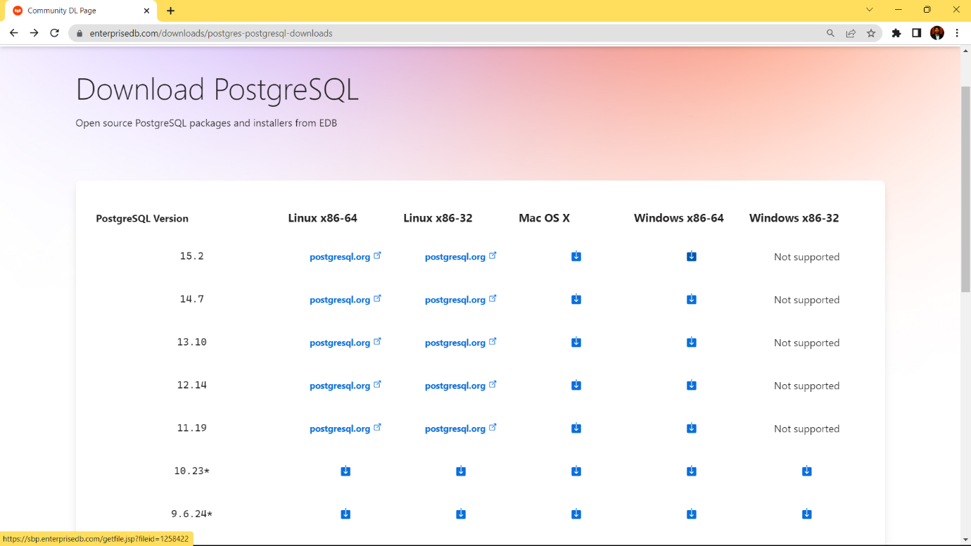

1. Run the installer and follow the prompts to install PostgreSQL on your system.

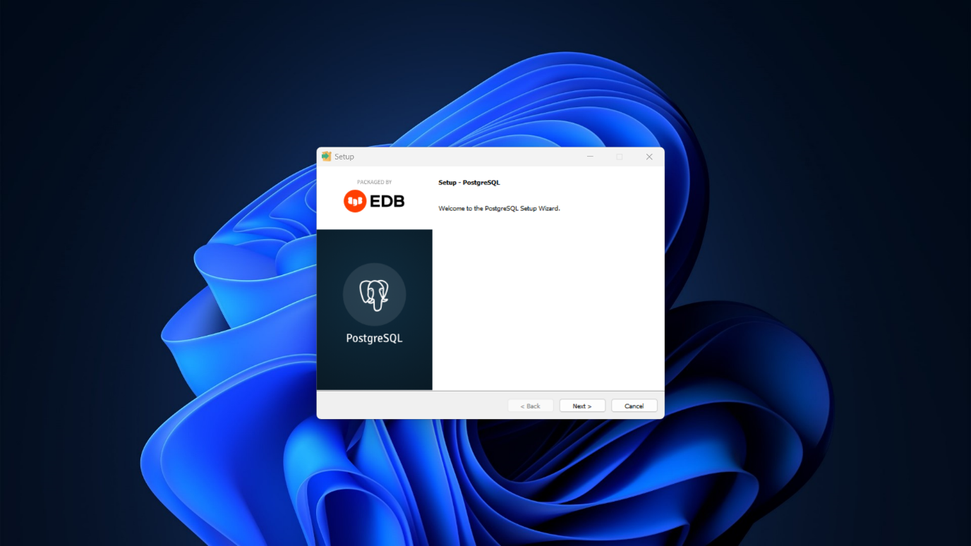

1. During the installation process, you will be prompted to create a PostgreSQL user account and set a password.
2. Once the installation is complete, open the PostgreSQL command prompt or the psql client to test your installation.

PostGIS Extension Installation Process:

1. Run the installer and follow the prompts to install the PostGIS extension on your system.

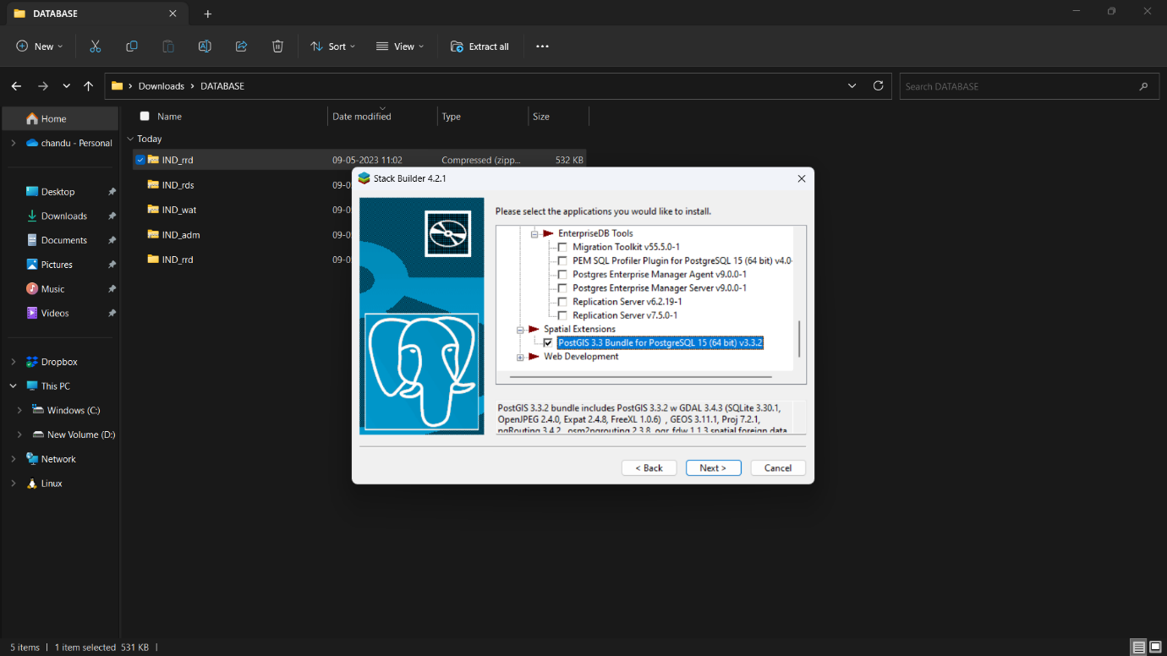

1. After the installation is complete, you need to enable the PostGIS extension in your PostgreSQL database. 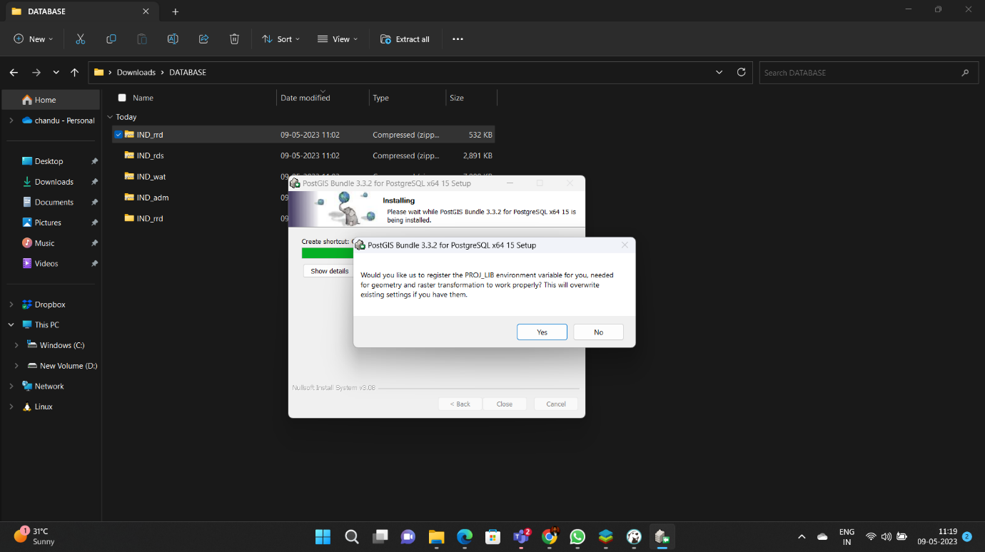
2. To do this, open a command prompt or terminal and connect to your PostgreSQL database using the psql client.
3. Once you are connected, run the following command to enable the PostGIS extension:

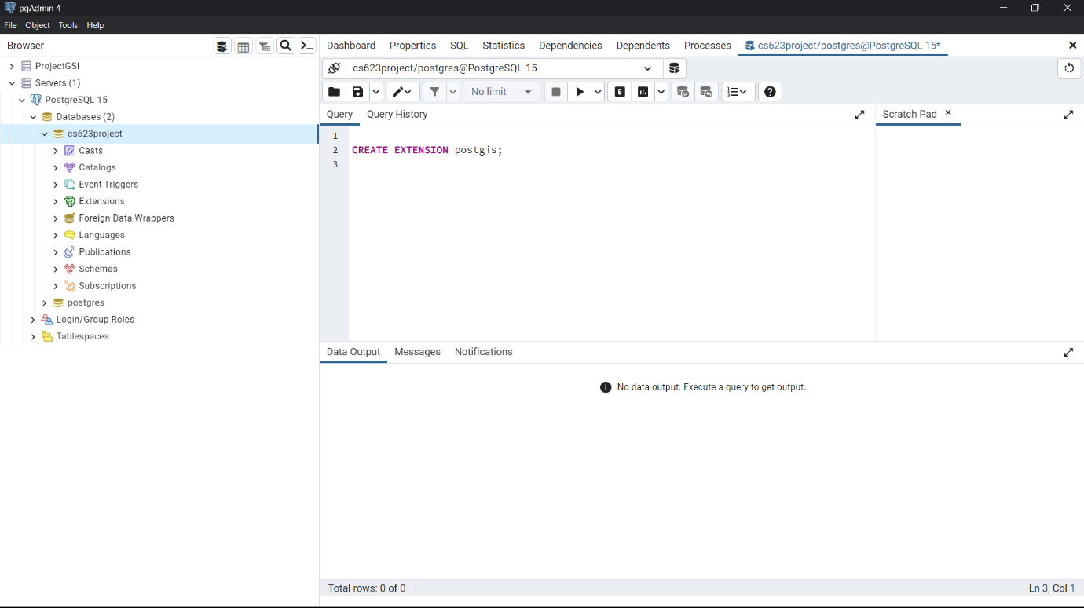

After installing PostGIS, the next step is to create a new database in PostgreSQL to store the spatial data. This can be done using the createdb command followed by the name of the database. For example, if you wanted to create a database called "cs623project ", you would enter the command createdb cs623project in the terminal.

Or we can create using UI.

Once the database has been created, the next step is to import the spatial data into PostGIS. To do this, you'll need to use the PostGIS Shapefile Import/Export Manager, which is a plugin that is included with QGIS. To open this tool, go to the "Plugins" menu in QGIS and select "PostGIS Shapefile Import/Export Manager".

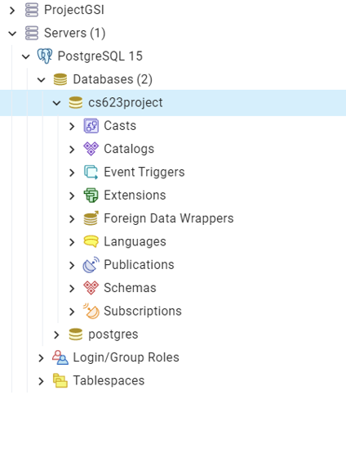

In the PostGIS Shapefile Import/Export Manager, click on "Connections" and enter the details for the database you created earlier, such as the host, port, database name, username, and password. Once the details have been entered, click on "Connect" to establish a connection to the database.

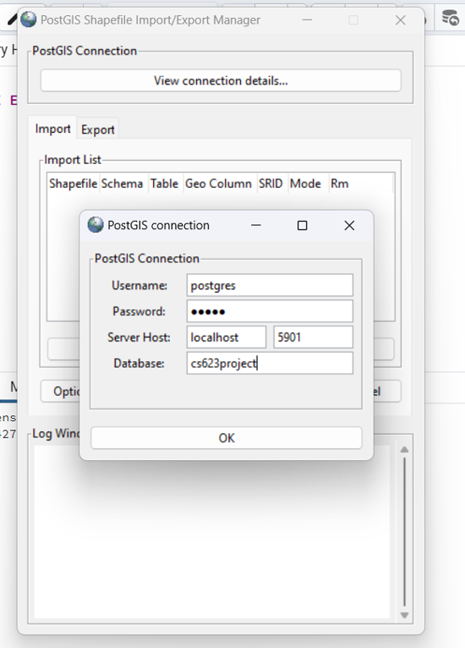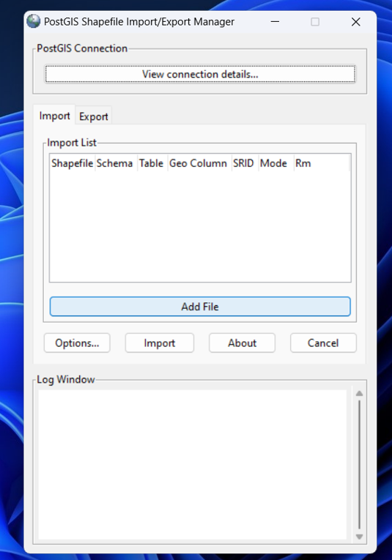

To import a spatial file into the database, click on "Add File" and browse to the location of the file. The file should be in shapefile format with the extension ".shp". Once the file has been selected, click on "Import" to start the import process.

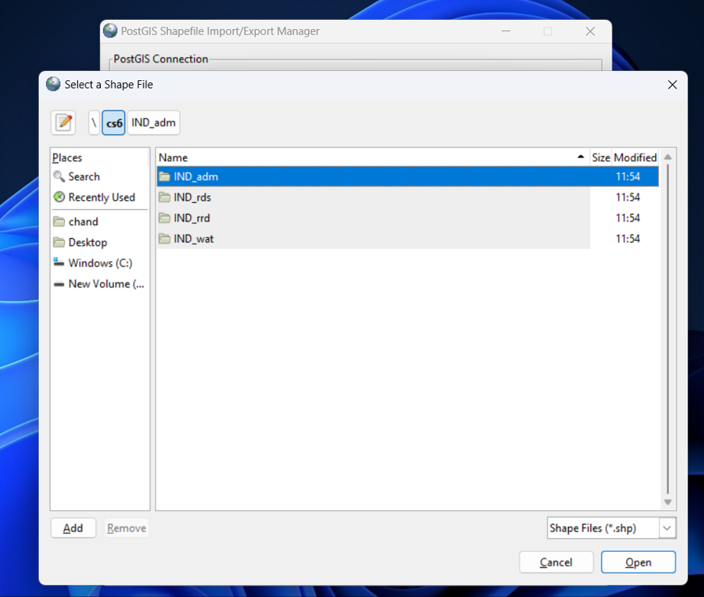

During the import process, you will be prompted to enter the SRID (Spatial Reference Identifier) for the data. The SRID is a unique code that identifies the coordinate system used by the data. You can find the SRID for your data by searching for the country object code in a spatial reference database.

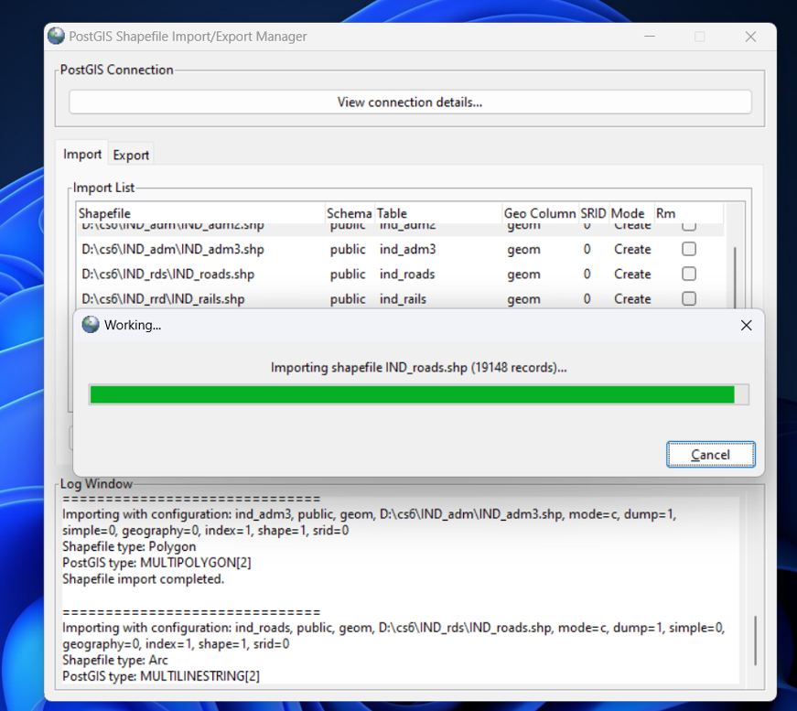

Once the SRID has been entered, click on "Import" to start the import process. PostGIS will create the necessary data tables based on the spatial data in the file. The time taken to import the data will depend on the size and complexity of the file, as well as the performance of your computer.

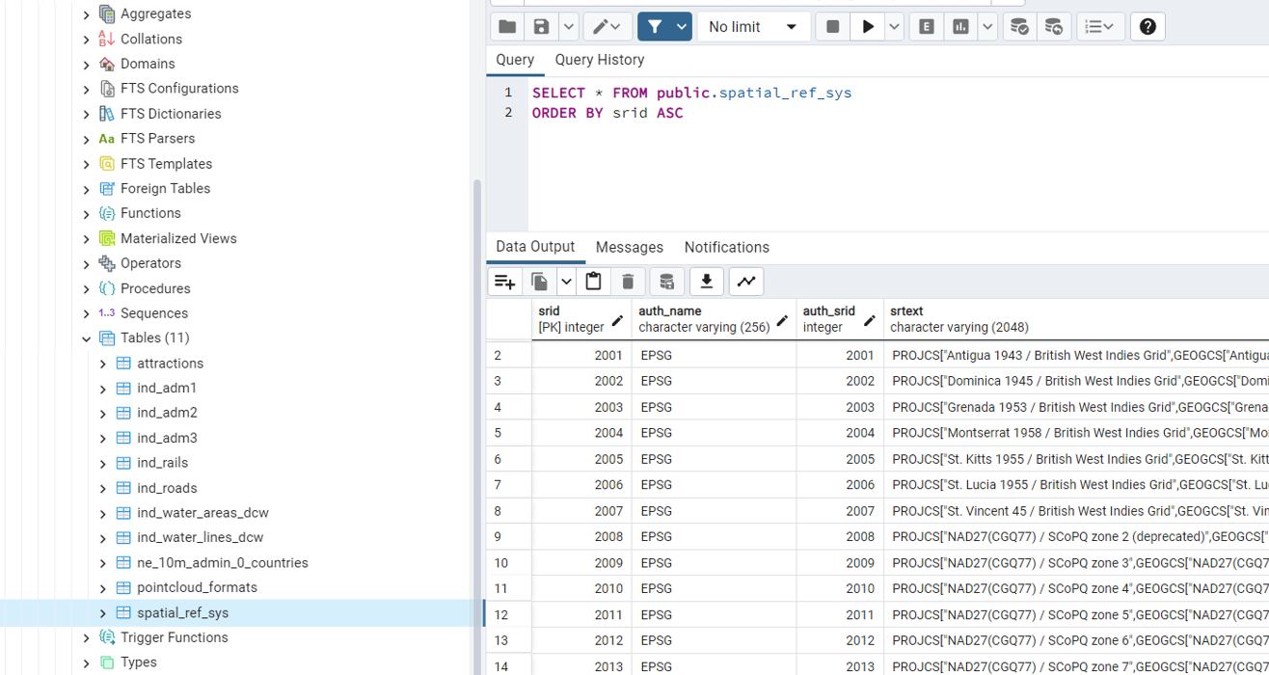

Once the import process is complete, you can use SQL queries and PostGIS functions to analyze and visualize the spatial data in your database. For example, you can use SQL queries to extract information about specific features in the data, or use PostGIS functions to perform spatial operations such as buffering or intersecting. With the spatial data now stored in PostGIS, you have a powerful tool for spatial analysis that can be used for a wide range of applications, from urban planning to environmental management.

Once the spatial data has been imported into the PostGIS database, the next step is to create tables based on your specific analysis requirements. This involves removing any unwanted columns and creating new tables that are better suited to your analysis needs.

To create a new table, you can use the CREATE TABLE statement followed by the name of the table and the column names and data types. For example, if you wanted to create a table called "mytable" with columns for "name", "population", and "geom".

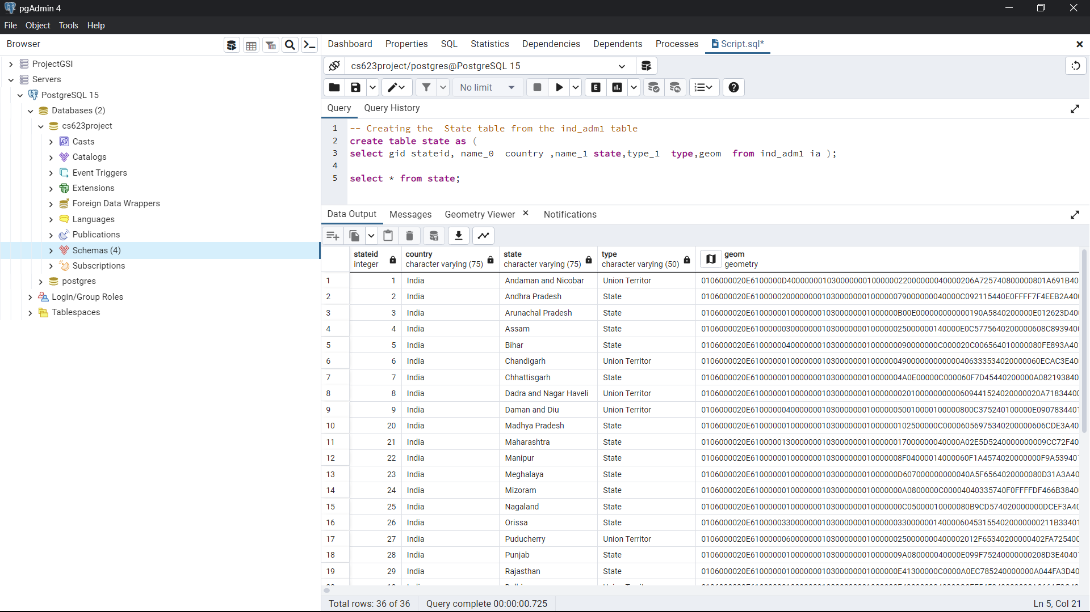

The above SQL statement creates a new table called "state" using data from an existing table called "ind_adm1". The new table includes columns for "stateid", "country", "state", "type", and "geom".

The "SELECT" statement is used to specify which columns should be included in the new table and where the data should come from. In this case, the "gid" column from the "ind_adm1" table is selected and renamed as "stateid" in the new table. Similarly, the "name_0", "name_1", "type_1", and "geom" columns are selected and renamed as "country", "state", "type", and "geom" respectively in the new table.

The "FROM" statement specifies the source table ("ind_adm1") from which the data should be retrieved.

Overall, this SQL statement creates a new table that includes the necessary columns and data for analyzing states in India. This table can be used in conjunction with other tables and queries to gain insights into spatial data related to Indian states.

In the same we are creating the city taluk , water area ,water line ,roads , railways , etc.

--state table create

create table state as (

select gid stateid, name_0 country ,name_1 state,type_1 type,geom from ind_adm1 ia )

--district table create

create table district as (

select id_2 distictid , name_1 state,name_2 district,type_2 type ,geom from ind_adm2 ia )

--taluka

create table taluk as (

select id_3 talukid ,name_0 country , name_1 state , name_2 taluk , type_3 type , geom from ind_adm3 ia )

--water areas

create table waterarea as (

select gid ,f_code_des , hyc_descri ,"name" geom from ind_water_areas_dcw iwad )

--water line

create table waterline as (

select gid , f_code_des , hyc_descri ,nam as name ,geom from ind_water_lines_dcw iwld )

--road

create table road as (

select gid , med_descri , rtt_descri type , geom from ind_roads ir )

--rail

create table rail as (

select f_code_des ,exs_descri use , fco_descri type,geom from ind_rails ir )

After Running the following commands we can check in Pgadmin.

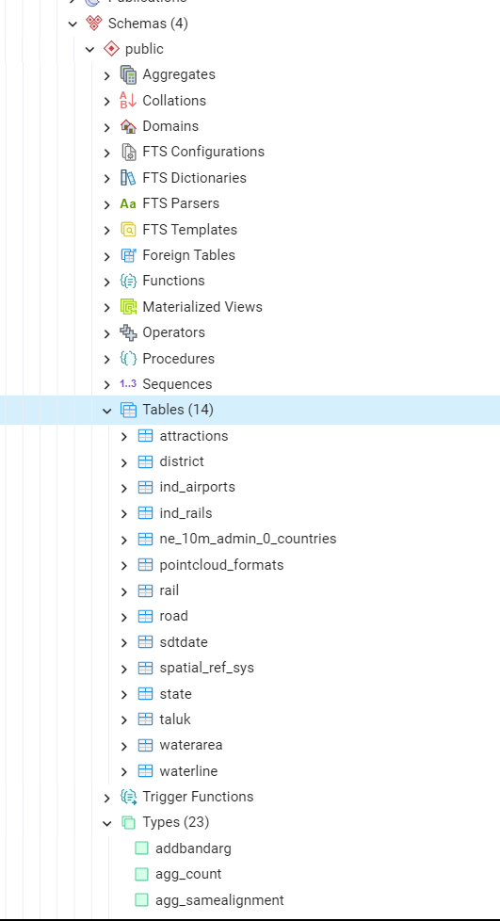

it is possible to visualize the spatial data directly within PostgresSQL using the built-in tool called pgAdmin. pgAdmin is a graphical user interface for managing PostgresSQL databases and it includes a built-in mapping tool that allows you to view spatial data on a map within the pgAdmin interface.

To view spatial data in pgAdmin, you can connect to your PostgresSQL database using pgAdmin and navigate to the table that contains the spatial data. You can then right-click on the table and select "View/Edit Data" and choose "Display Data on Map" to visualize the data on a map within the pgAdmin interface.

The mapping tool in pgAdmin allows you to zoom, pan, and interact with the map and the data, and you can also customize the visualization by changing the symbology, colors, and labels of the data. This can be a quick and convenient way to view and analyze your spatial data within the same environment as your database management.

We can analyse the data and summarise :

In the context of administrative divisions in India, a state is a unit of the country that is organized under a single government and has its own administrative structure. India is divided into 28 states and 8 union territories.

For State :

A district is a local administrative division within a state, typically smaller than a state but larger than a taluk or tehsil. Districts are further divided into sub-districts or tehsils, which in turn are divided into smaller administrative units called blocks or taluks. Districts are responsible for the administration of law and order, revenue collection, and provision of essential services like healthcare and education.

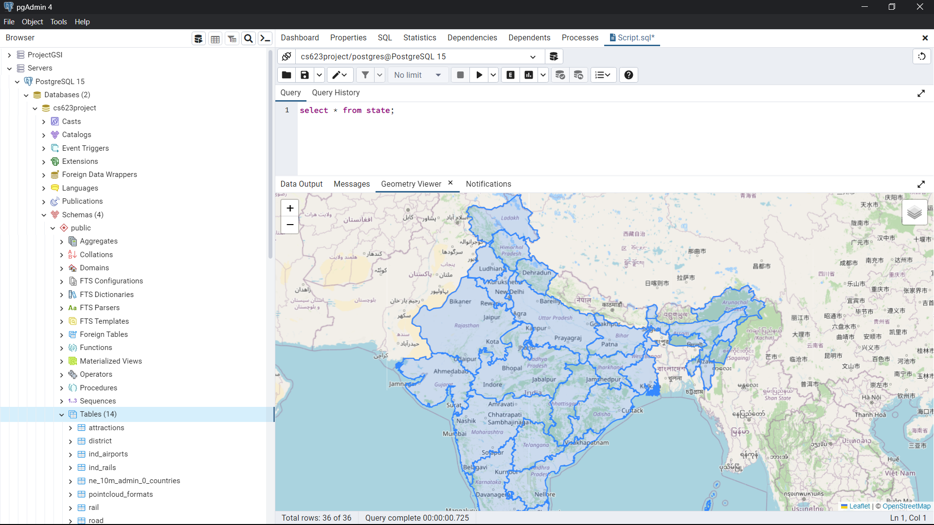

For District:

A taluk or tehsil is a sub-district administrative unit within a district, typically comprising a cluster of villages or towns. Taluks are responsible for the administration of local services and infrastructure, such as water supply, electricity, and road maintenance. Taluks are further divided into smaller units called revenue villages or gram panchayats.

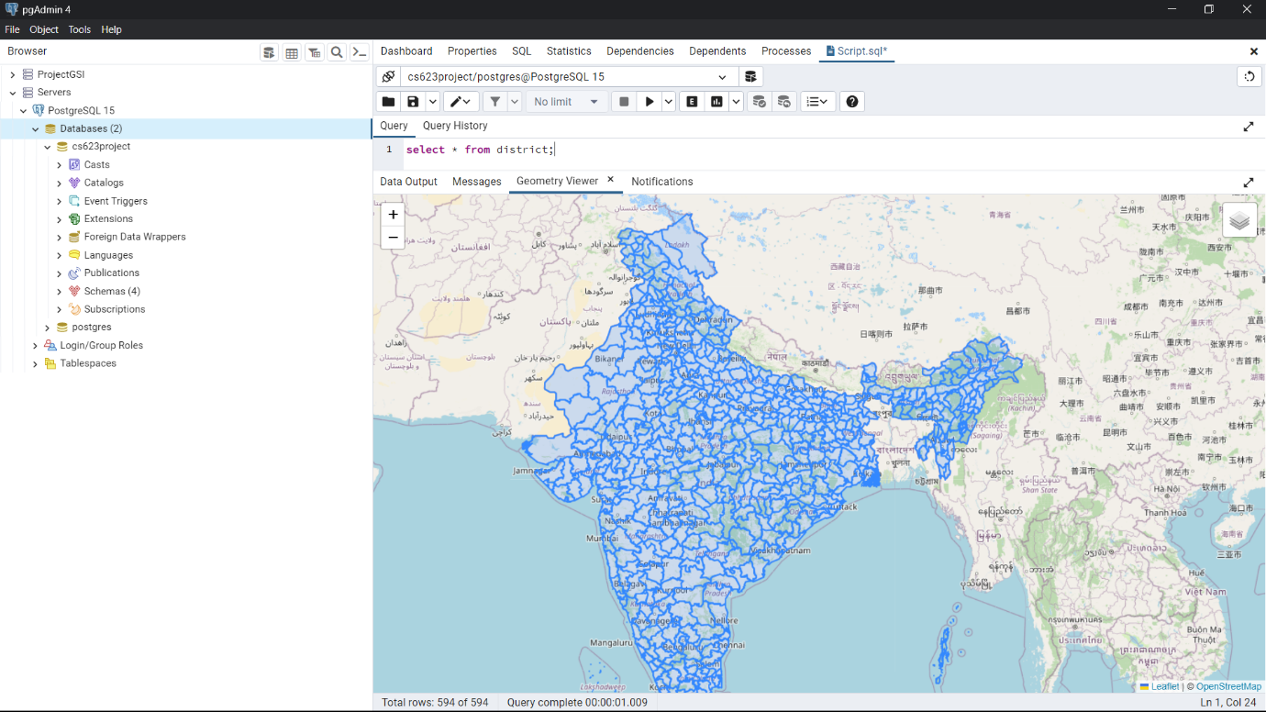

For taluk:

These administrative divisions are used by the Indian government for purposes of governance, administration, and service delivery. Understanding the hierarchy and structure of these divisions can be important for conducting spatial analysis and making informed decisions based on spatial data.

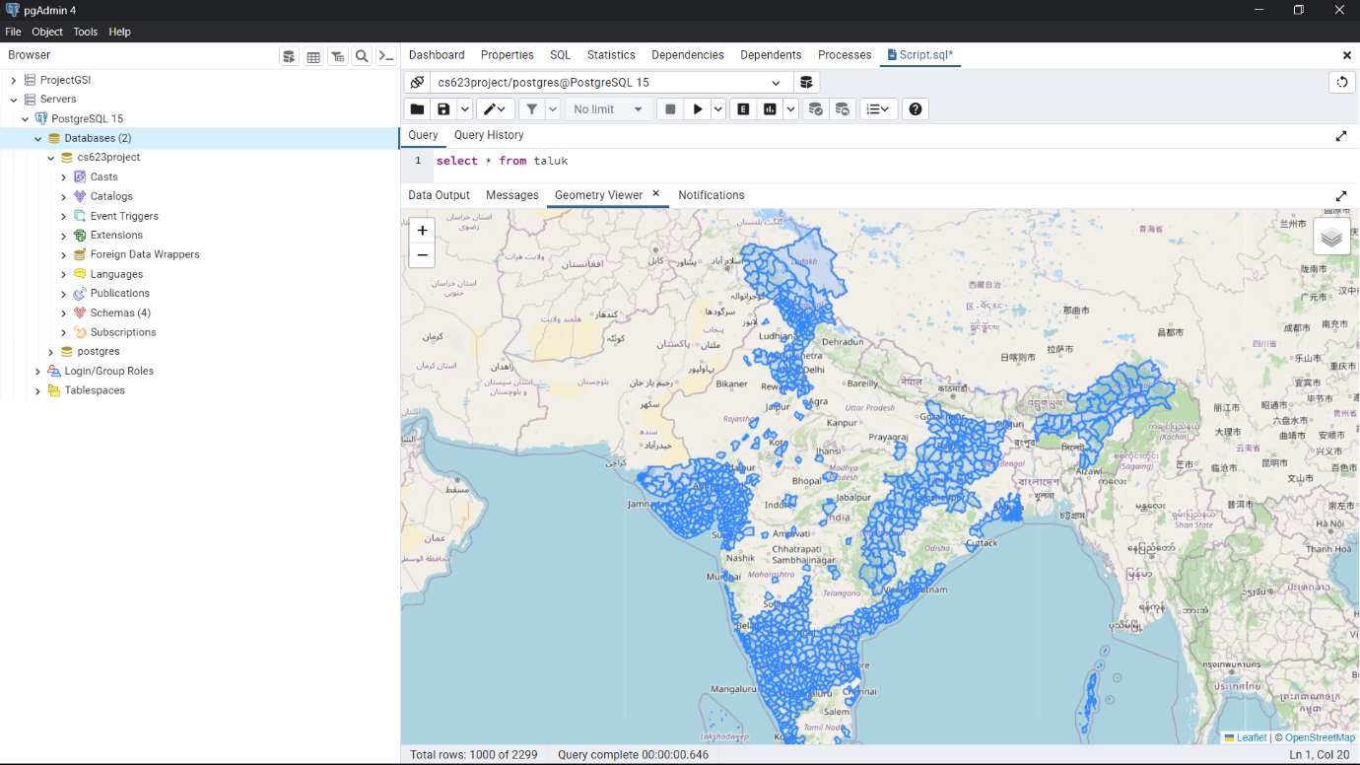

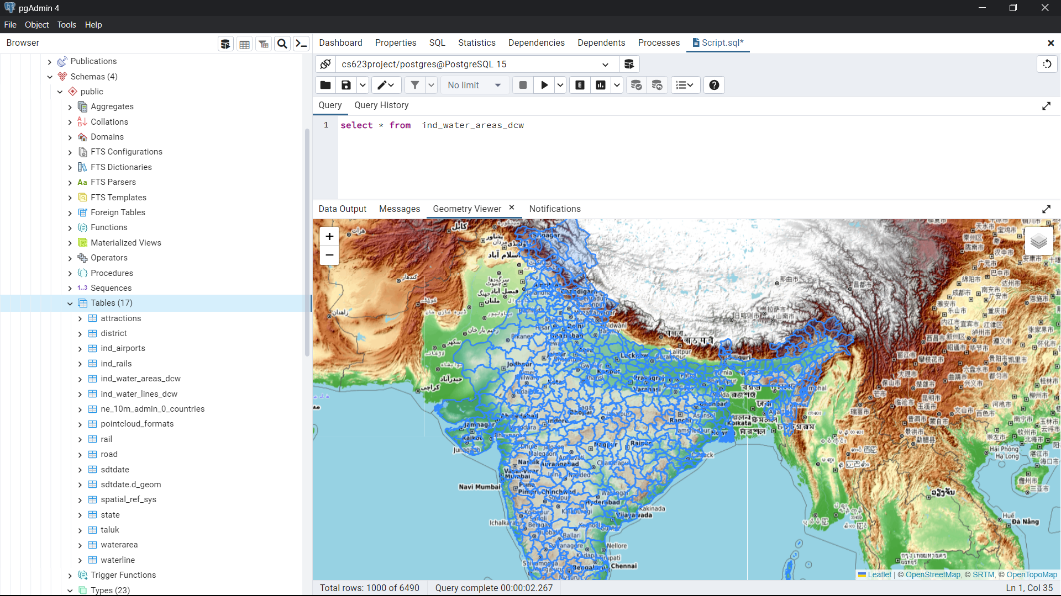

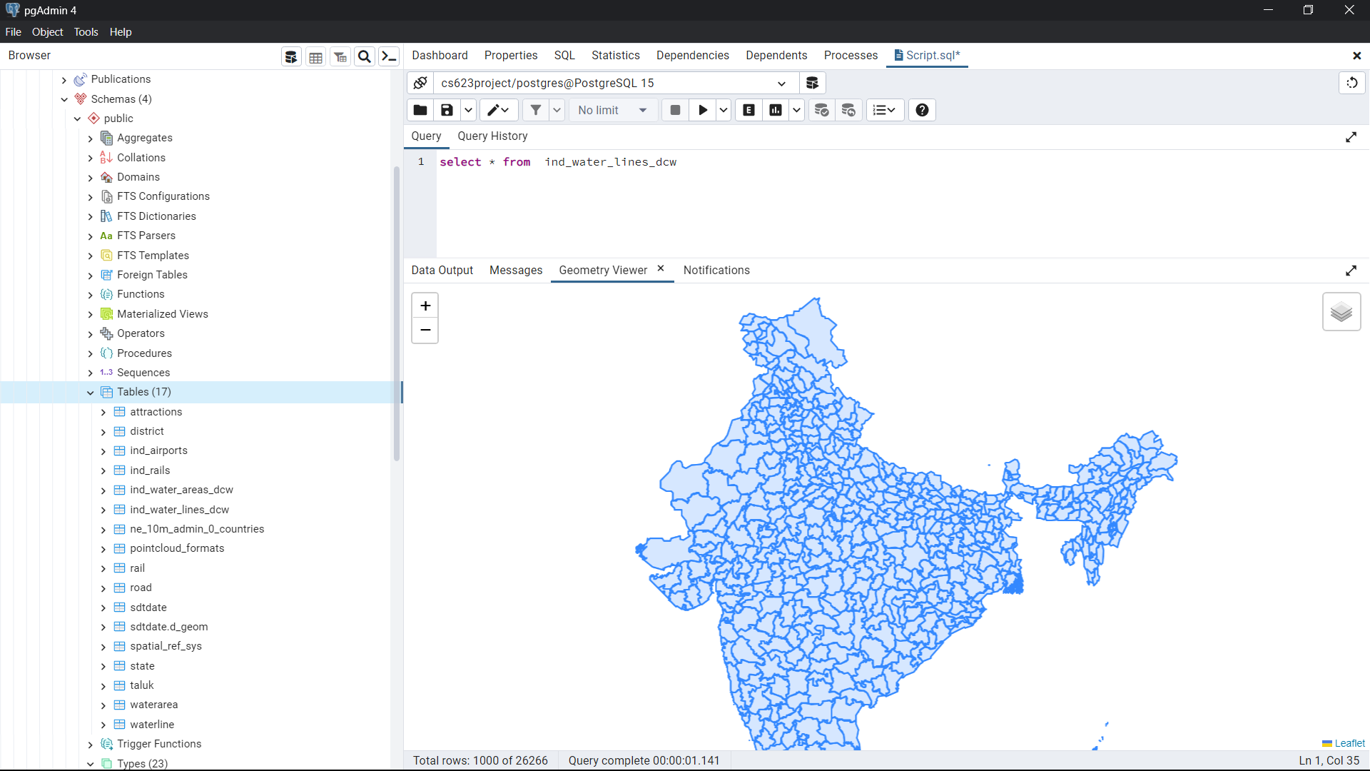

after creating the necessary tables in PostgresSQL with the desired columns and data, you can select and view them in a variety of ways. One way is to use a GIS application or software that can connect to the Postgres database and display the data on a map or in a table.

Another way is to use SQL queries to extract and manipulate the data in Postgres and then view the results in a table or on a map in a UI (user interface) or dashboard. Some popular GIS applications that support Postgres include QGIS, ArcGIS, and MapInfo.

By visualizing the spatial data in a UI, you can gain insights into patterns, trends, and relationships that may not be immediately obvious from the raw data. This can help you make more informed decisions and predictions based on the spatial data you have analyzed.

If you have already installed QGIS you can open QGIS Desktop 



In the Browse click on postgres.

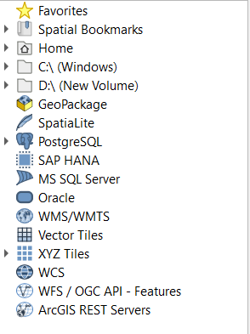

After clicking into it give the dbdetails

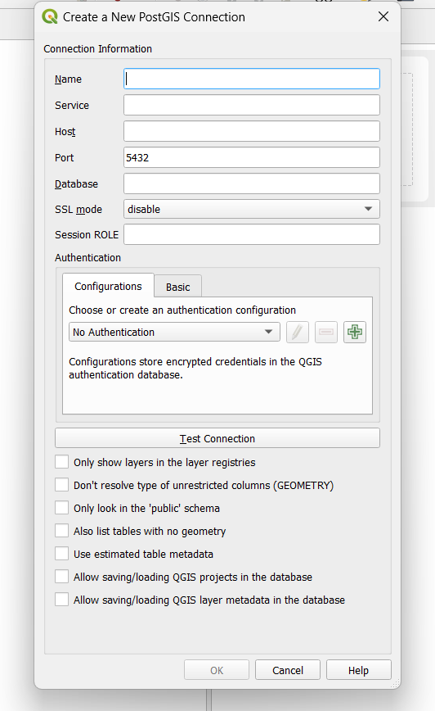

After successful connection we can view the graphicial data

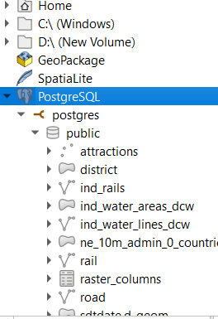

We can create the visuals by simply click on it.

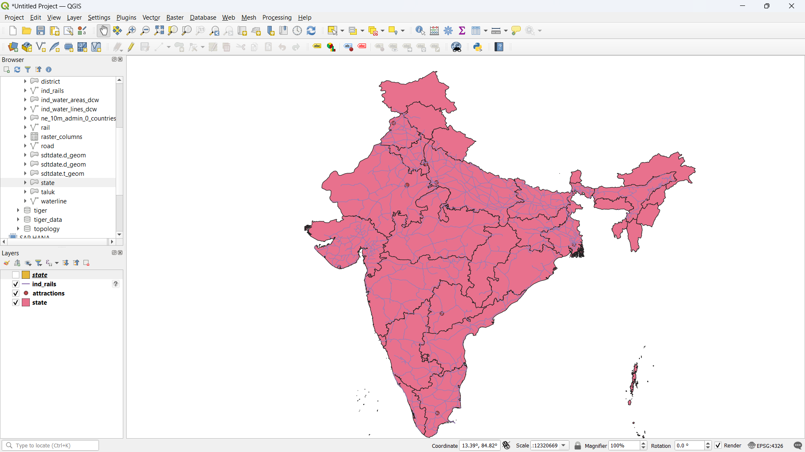

But is only what we can do with our data and visual part we can get it into our main part.

2. Calculate Distance between points :

1. ST_DistanceSphere(geom1, geom2): This function calculates the great-circle distance between two points on the surface of a sphere, using the Haversine formula. The result is returned in meters, which is the default unit of measurement for this function.

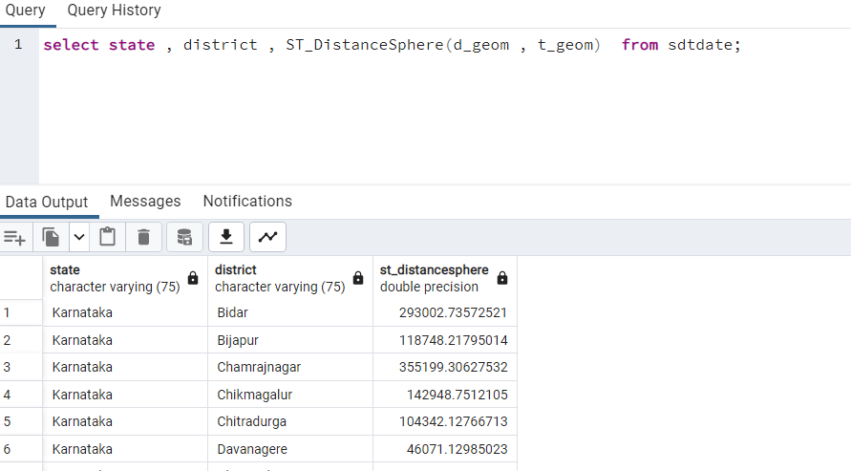

1. ST_DistanceSpheroid(geom1, geom2, spheroid): This function calculates the distance between two points on the surface of a spheroid, which is a more accurate model of the Earth's shape than a sphere. The spheroid argument specifies the spheroid to use, and is represented as a string in Well-Known Text (WKT) format. The result is returned in meters, which is the default unit of measurement for this function.

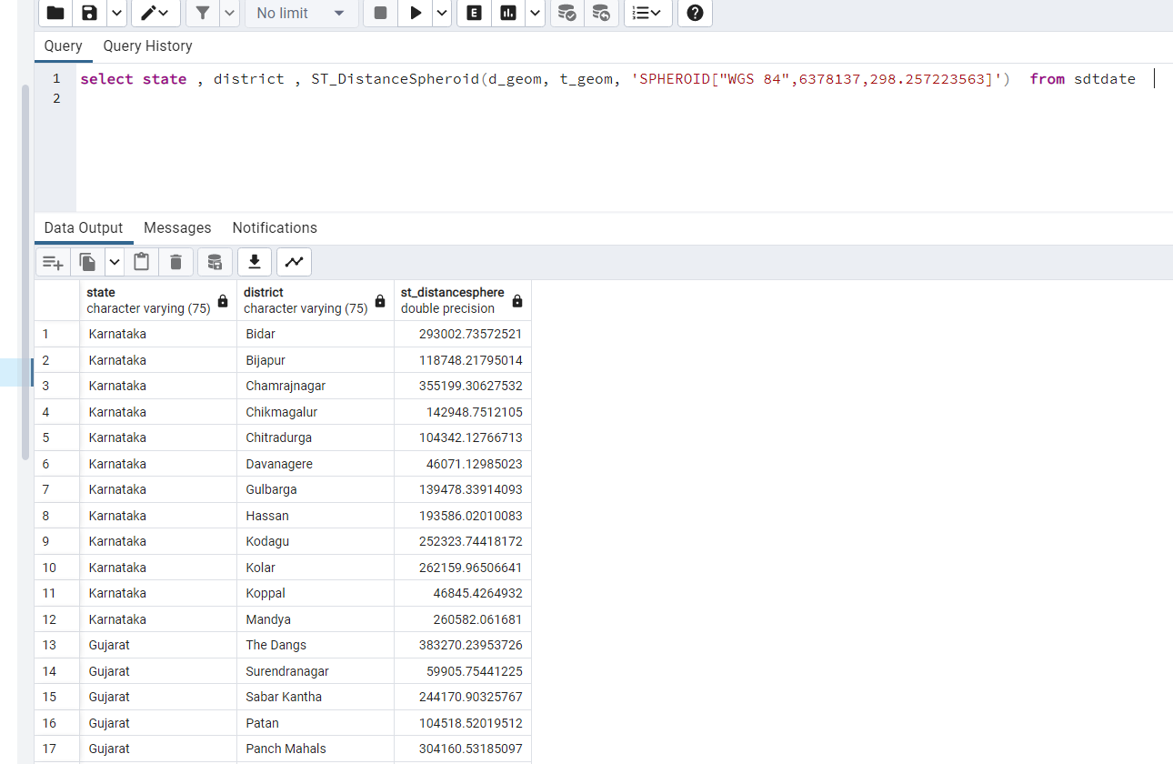

1. ST_Distance(geom1::geography, geom2::geography): This function calculates the distance between two points on the Earth's surface using a geodetic coordinate system. The ::geography cast is used to convert the geometries to the geography data type, which allows distance calculations to be performed using meters as the unit of measurement. The result is returned in meters. 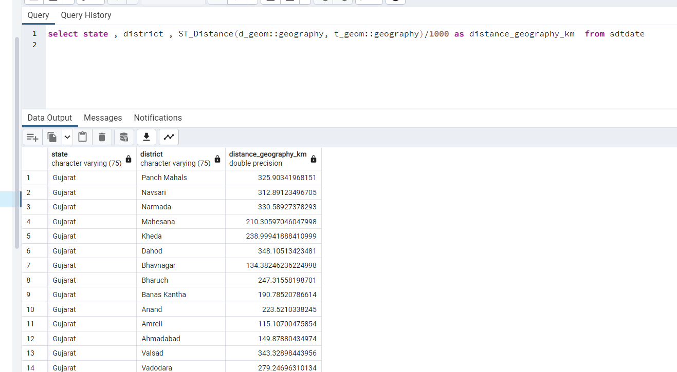
2. ST_Distance(geom1::geography, geom2::geography)/1000: This is similar to the previous function, but the result is divided by 1000 to convert meters to kilometers. 
3. ST_Distance(geom1::geography, geom2::geography)/1609.34: This is also similar to the previous function, but the result is divided by 1609.34 to convert meters to miles. 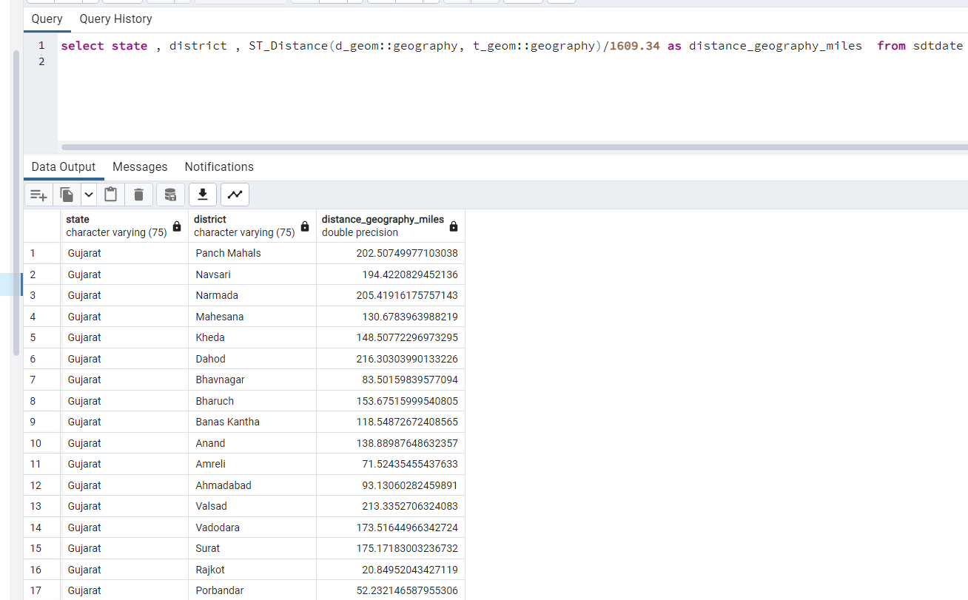
4. ST_Distance(geom1, geom2): This function calculates the distance between two points in a Cartesian coordinate system. The result is returned in the units of measurement used by the coordinate system, which depend on the units specified in the spatial reference system of the geometries.

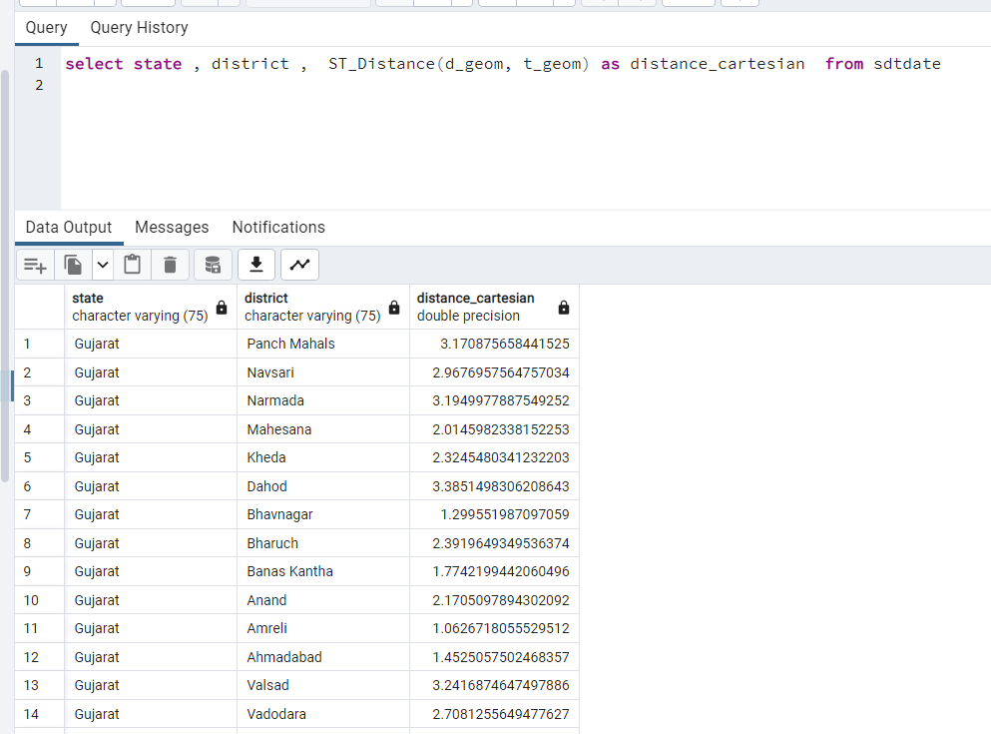

We can also use the following query to get all the calculations.

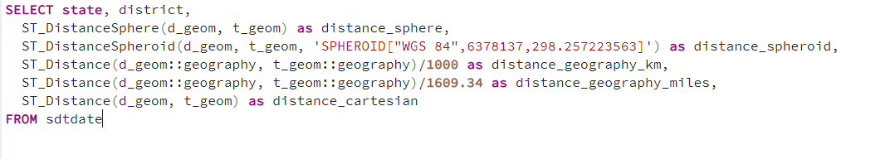

3.Calculate Areas of Interest:

PostGIS functions for calculating areas of interest, depending on the type of geometry and the desired unit of measurement.

1. ST_Area(geom): This function calculates the area of a geometry in its native units, which depend on the spatial reference system used by the geometry.

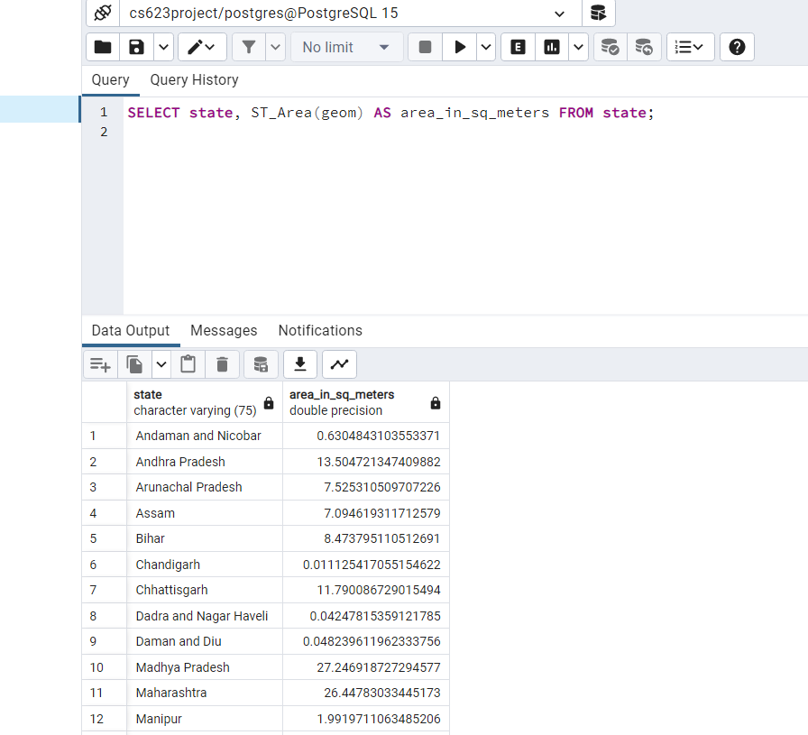

1. ST_Area(geom::geography): This function calculates the area of a geometry in square meters, using a geodetic coordinate system. The ::geography cast is used to convert the geometry to the geography data type, which allows area calculations to be performed using square meters as the unit of measurement.

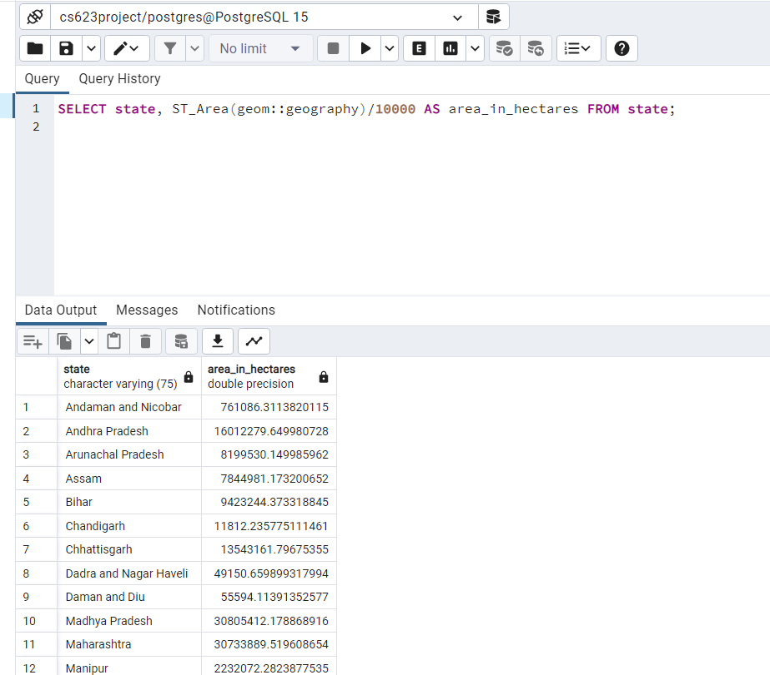

1. ST_Area(geom::geography)/10000: This is similar to the previous function, but the result is divided by 10,000 to convert square meters to hectares.

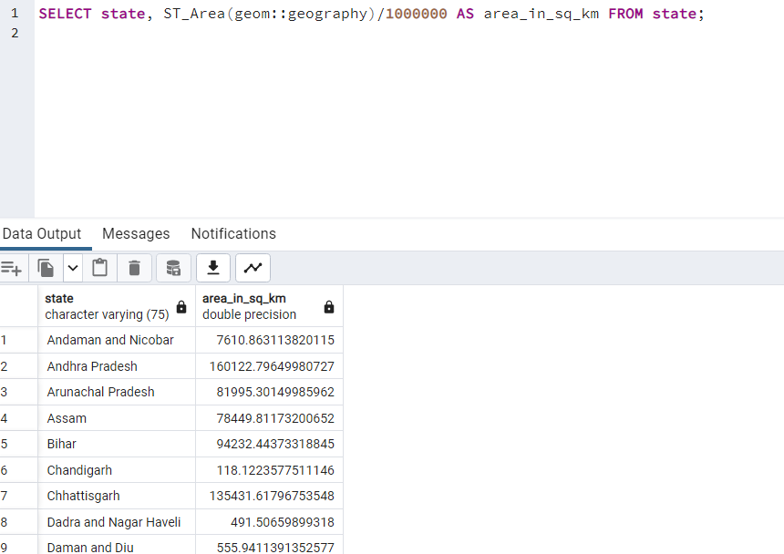

1. ST_Area(geom::geography)/1000000: This is also similar to the previous function, but the result is divided by 1,000,000 to convert square meters to square kilometers.



1. ST_Area(geom::geography)*0.000247105: This function converts the area of a geometry in square meters to acres.

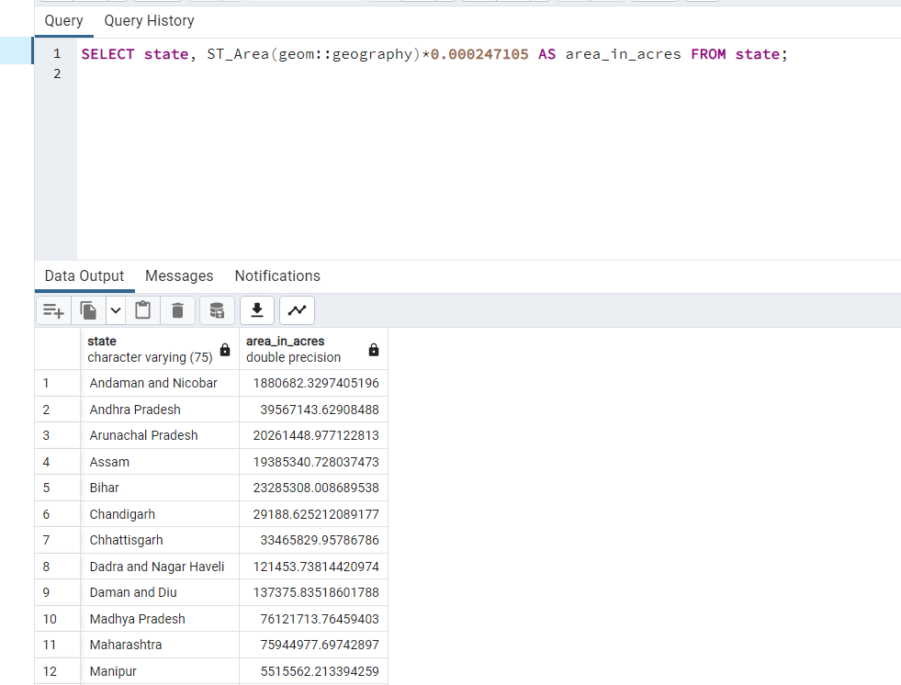

1. ST_Area(geom::geography)*0.000000386102: This function converts the area of a geometry in square meters to square miles.

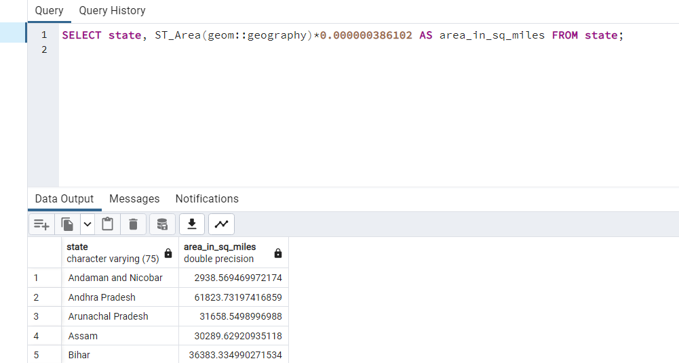

Area of the Square feet :

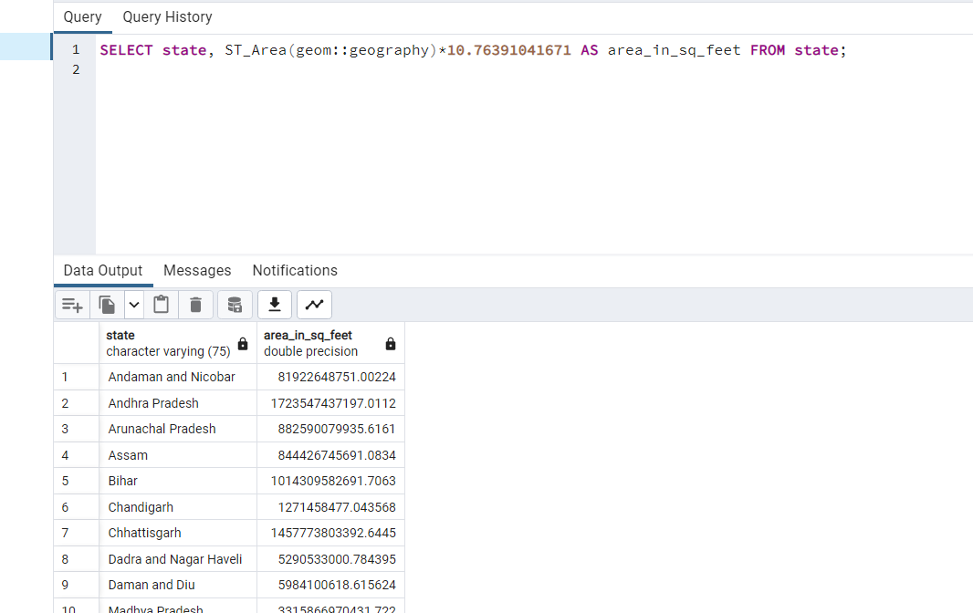

1. Analyze the queries :

To analyze the performance of a query, you can use the built-in tools provided by PostgreSQL, such as EXPLAIN and EXPLAIN ANALYZE.

EXPLAIN: This command shows the query plan generated by the PostgreSQL query optimizer, without actually executing the query. It can help you understand how the optimizer plans to execute the query, which indexes it plans to use, and other useful information about the query plan. To use EXPLAIN, simply prepend it to your query, like this:

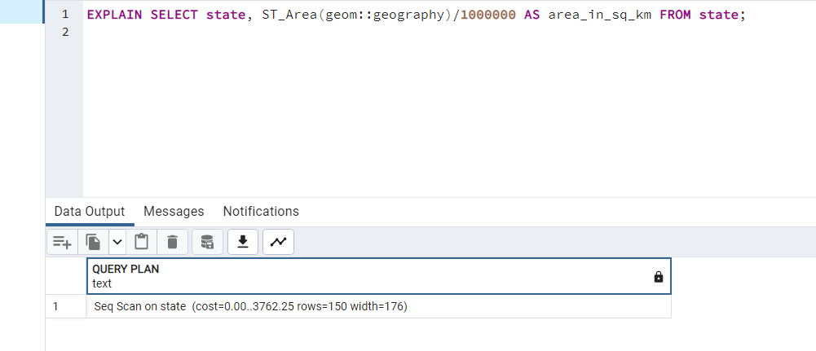

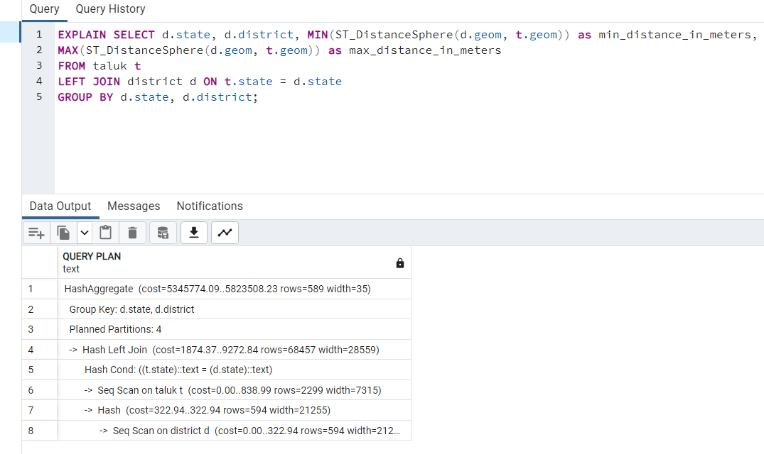

The EXPLAIN output provides information about how the PostgreSQL query planner will execute the query. Here's what each line means:

1. GroupAggregate: This line shows that the query is performing a group aggregation operation (i.e., grouping the results by state and district and calculating min and max distances).
2. cost=551.95..582.13 rows=36 width=88: This line shows the estimated cost of executing the query, which is based on factors like the number of rows being processed, the number of tables being joined, and the complexity of the calculations being performed. The estimated cost ranges from 551.95 to 582.13, and the result will have 36 rows and a width of 88 bytes.
3. Group Key: d.state, d.district: This line shows the grouping key, which is the combination of the state and district columns from the district table.
4. Sort: This line shows that the results will be sorted by state and district.

cost=551.95..558.78 rows=2732 width=76: This line shows the estimated cost of the sorting operation, which ranges from 551.95 to 558.78. The result will have 2732 rows and a width of 76 bytes.

1. Hash Left Join: This line shows that the query will perform a hash-based join operation between the taluk and district tables.
2. Hash Cond: (t.state = d.state): This line shows the join condition, which is that the state column in the taluk table matches the state column in the district table.
3. Seq Scan on taluk t: This line shows that the taluk table will be scanned sequentially (i.e., row-by-row).
4. Seq Scan on district d: This line shows that the district table will be scanned sequentially.

width: This line shows the estimated width of the resulting rows in bytes.

1. Overall, the EXPLAIN output shows that the query will perform a relatively simple join and aggregation operation, and that the estimated cost of the query is relatively low.

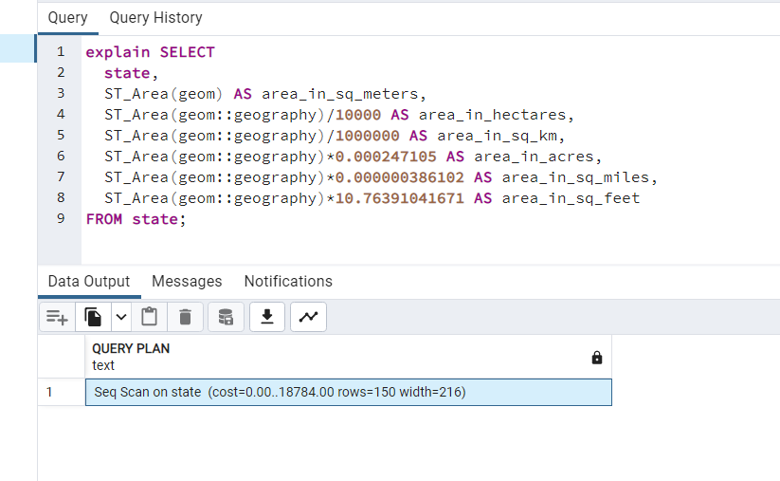

case of the message "Seq Scan on state (cost=0.00..18784.00 rows=150 width=216)", it means that PostgreSQL is performing a sequential scan on the "state" table, which means it is scanning each row of the table in order. The cost of the query is estimated to be between 0 and 18,784 units (the units depend on the specific PostgreSQL configuration), and the estimated number of rows returned is 150. The width of the rows being returned is 216 bytes.

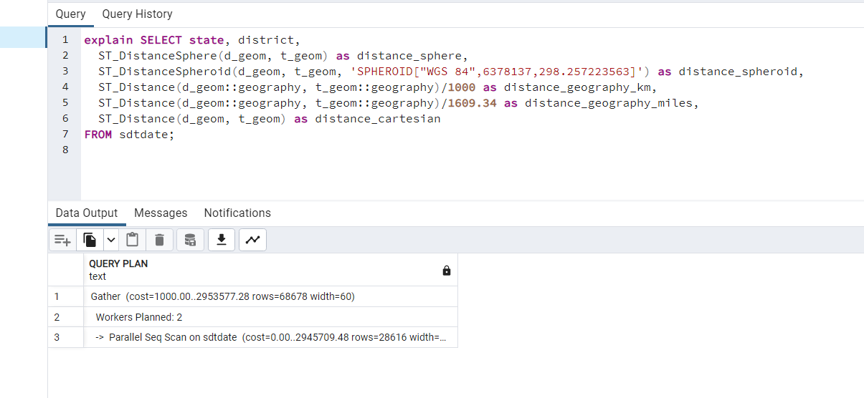

The "Gather" line indicates that the query is running in parallel across three workers (two planned workers and one coordinator).

The "cost" column represents the estimated cost of each operation in the query, which is measured in arbitrary units. The total cost of the query is 1000.00, which is the cost of the gather operation.

The "rows" column represents the estimated number of rows that will be returned by each operation in the query. The first line indicates that the query is expected to return 68,678 rows, while the second line indicates that the sequential scan is expected to return 28,616 rows.

Overall, this output suggests that the query is running efficiently and utilizing parallel processing to speed up execution.

Sorting and Limit Executions:

In PostgreSQL, the ORDER BY and LIMIT clauses are used for sorting and limiting the results of a query.

The ORDER BY clause is used to sort the result set in ascending or descending order based on one or more columns.

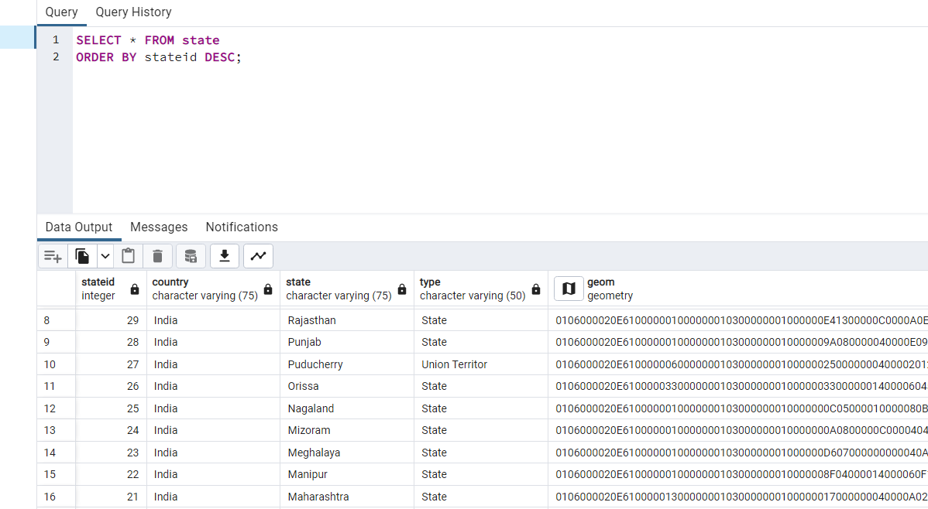

The LIMIT clause is used to limit the number of records returned by a query. For example, the following query returns only the first 10 records from the state table:

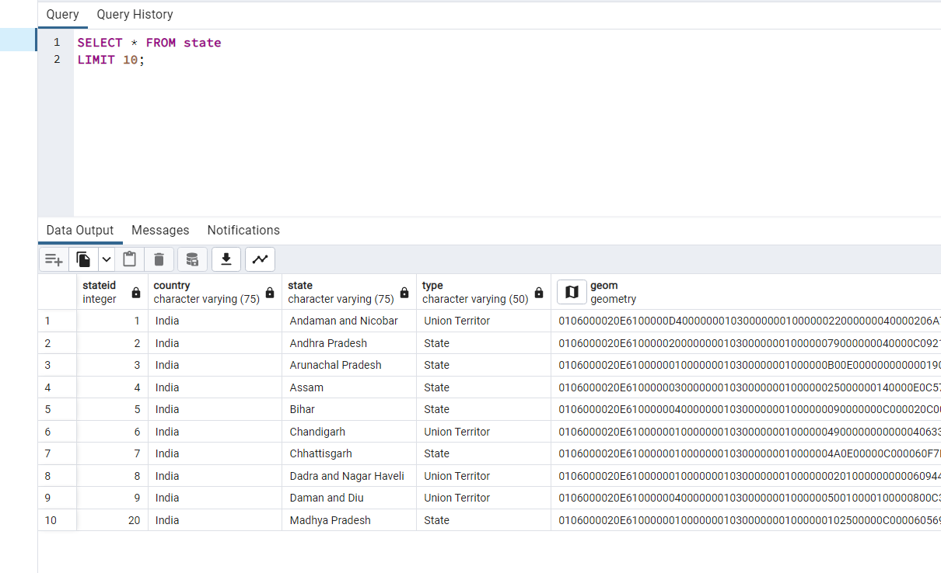

In addition to ORDER BY and LIMIT, there are other clauses that can be used for sorting and limiting in PostgreSQL, such as OFFSET, FETCH, and TOP

OFFSET: Used to skip a specified number of rows before returning the remaining rows. For example, the following query skips the first 10 rows and returns the next 10 rows:

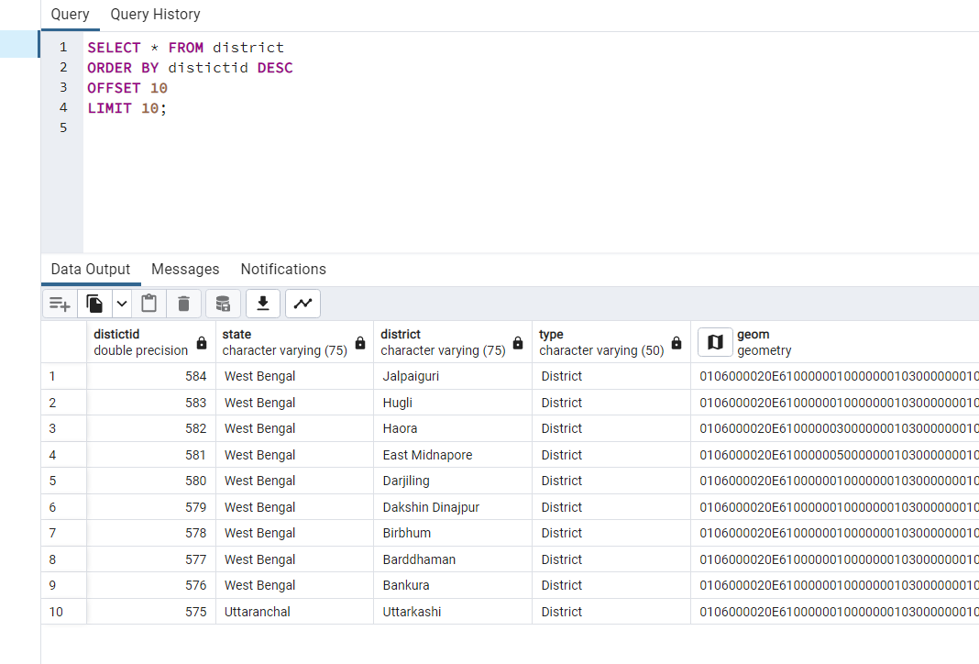

FETCH: Used to limit the number of rows returned and optionally specify an offset. This is an alternative to using LIMIT and OFFSET separately

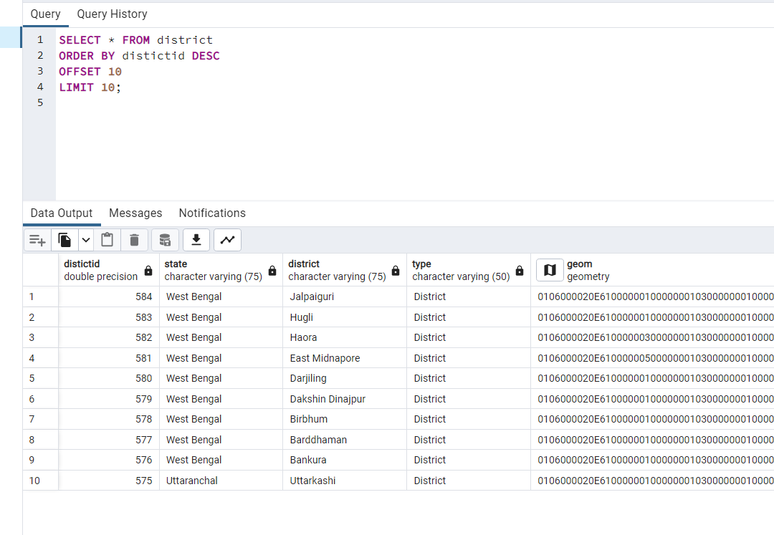

DISTINCT: Used to remove duplicate rows from the result set based on one or more columns. For example, the following query returns a list of unique states from the orders table:

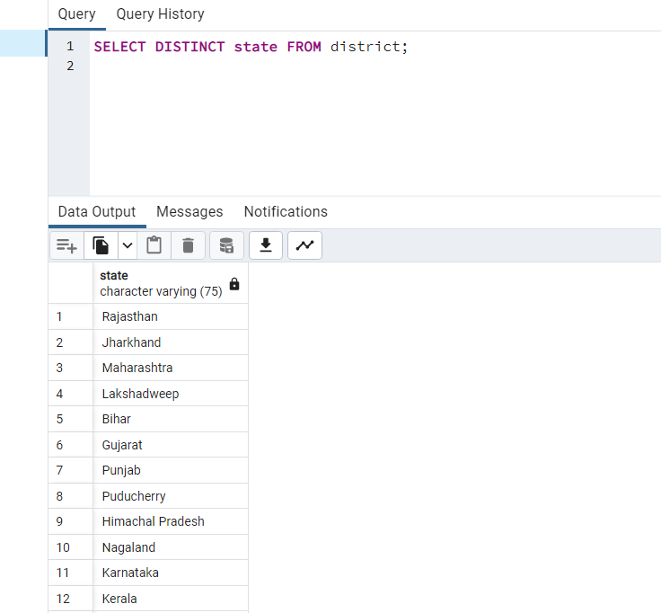

GROUP BY: Used to group the result set by one or more columns and perform aggregate functions on the grouped data, such as SUM, AVG, MAX, and MIN. For example, the following query returns the total sales for each state:

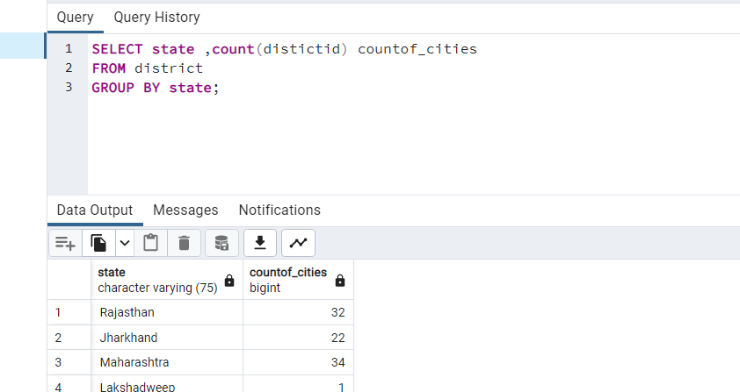

HAVING: Used to filter the results of a GROUP BY query based on a condition. For example, the following query returns only the states with total sales greater than $1 million:

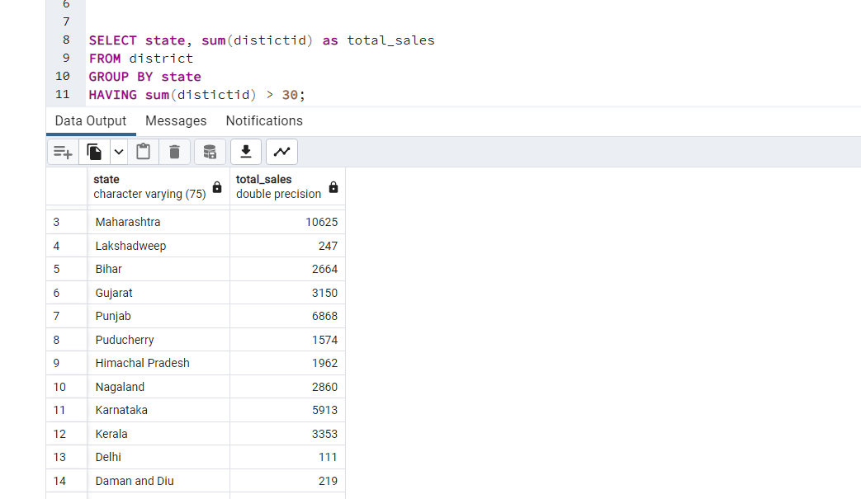

some examples of applying different functions:

Sorting by area in descending order:

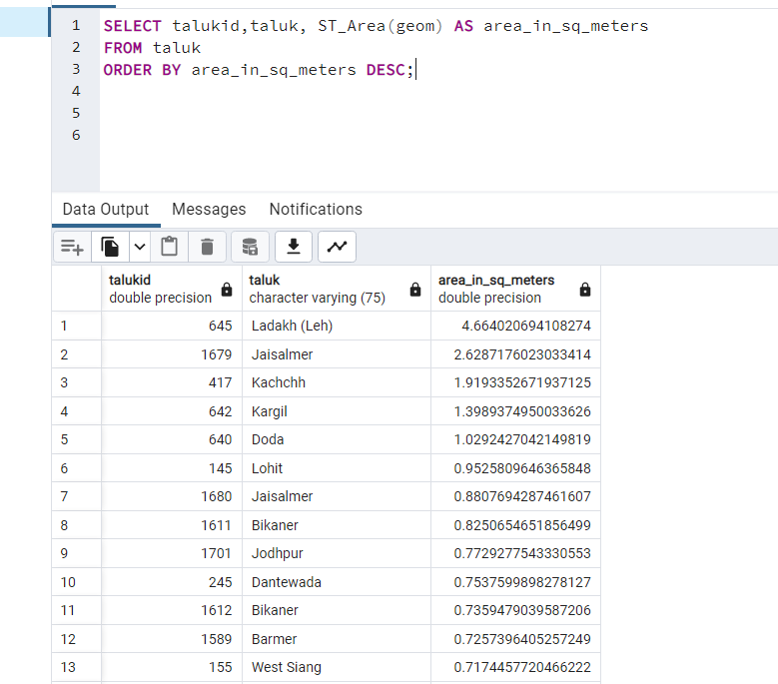

Limiting the results to the top 10 largest areas:

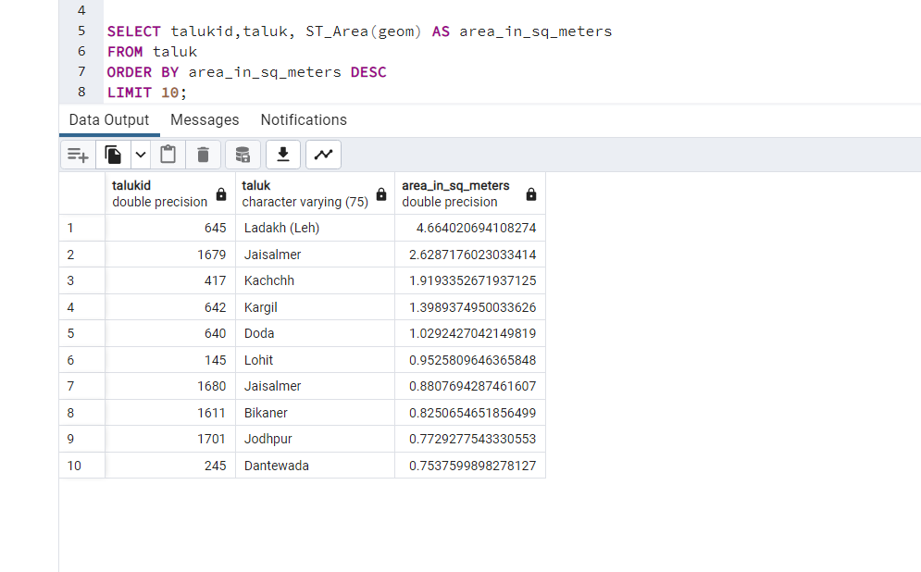

Converting the area from square meters to square kilometers:

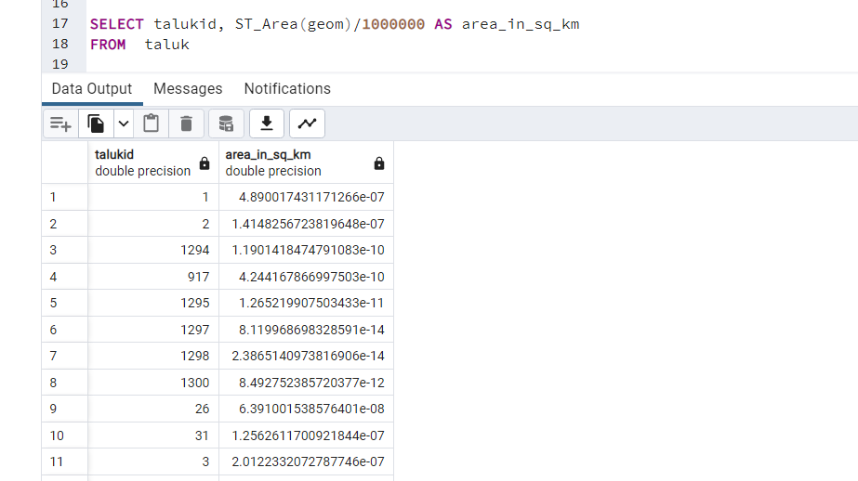

Filtering the results to include only buildings with an area larger than 1000 square meters:

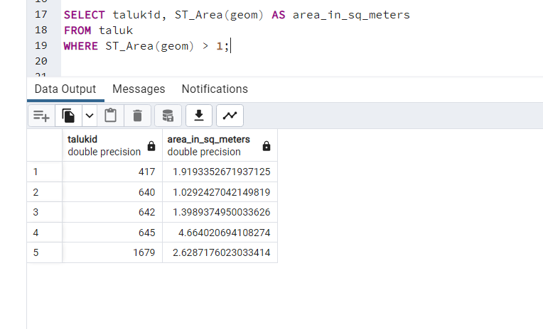

6.Optimize the queries to speed up execution time:

In PostgreSQL, there are several types of indexes that can be used to speed up query execution:

1. B-tree index: This is the default index type in PostgreSQL, and it is suitable for general-purpose indexing.
2. Hash index: This index type is suitable for equality queries, where the index key is compared using the "=" operator.
3. GiST (Generalized Search Tree) index: This index type is suitable for complex data types like geometric shapes, text, and arrays.
4. GIN (Generalized Inverted Index) index: This index type is suitable for full-text search and array data types.
5. SP-GiST (Space-Partitioned Generalized Search Tree) index: This index type is suitable for spatial data types like geometric shapes.
6. BRIN (Block Range INdex) index: This index type is suitable for large tables with a natural sort order, like time series data.
7. Bitmap index: This index type is used for low-selectivity conditions like boolean fields, where only a small percentage of the rows match the condition.

The choice of index type depends on the specific query and data characteristics.

B-tree index: This is the default index type in Postgres and is used for indexing single or multiple columns. B-tree indexes are most effective when querying data with range or equality conditions.

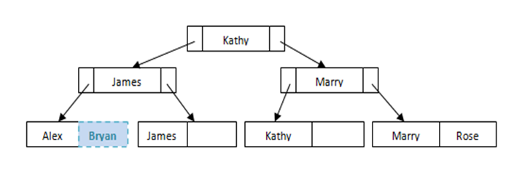

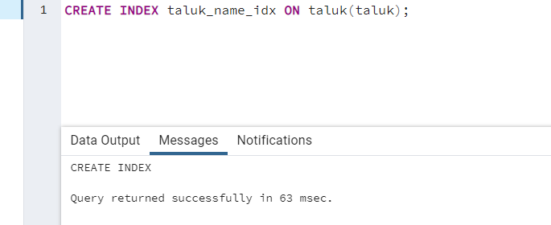

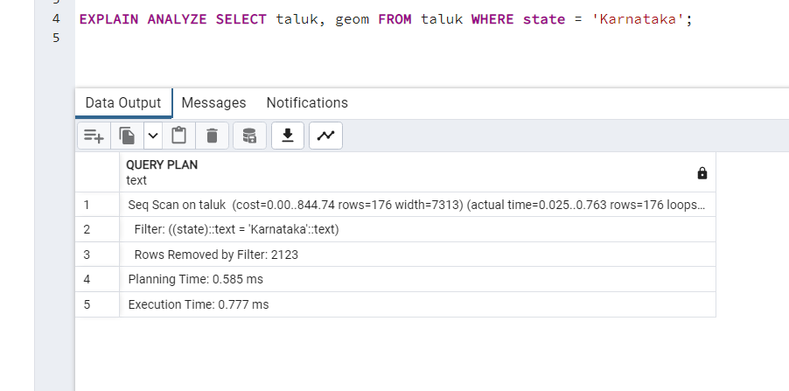

This output is the result of the EXPLAIN command for a query that filters rows from the taluk table where the state column is equal to 'Karnataka'.

The output shows that the PostgreSQL planner estimated the cost of this query to be 0.00..844.74. This cost represents an estimation of how many disk I/O operations and CPU cycles the query will require to execute.

The actual time it took to execute the query was 0.025..0.763 seconds, with 176 rows returned.

The output also shows that the PostgreSQL planner used a sequential scan (Seq Scan) to retrieve the rows from the taluk table, which means that it read the table row by row to find the ones that match the filter. This can be a slower approach for larger tables, but can still be efficient when there are only a small number of matching rows.

The Planning Time and Execution Time values represent the time it took for PostgreSQL to plan the query and execute it, respectively.

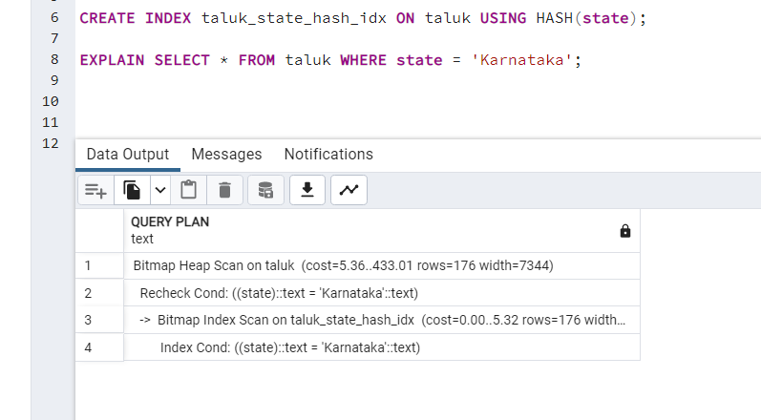

3. GiST (Generalized Search Tree) index: This index type is used for indexing complex data types, such as geometric data or full-text search data. GiST indexes can be used to speed up spatial queries, like finding points within a certain distance of each other.

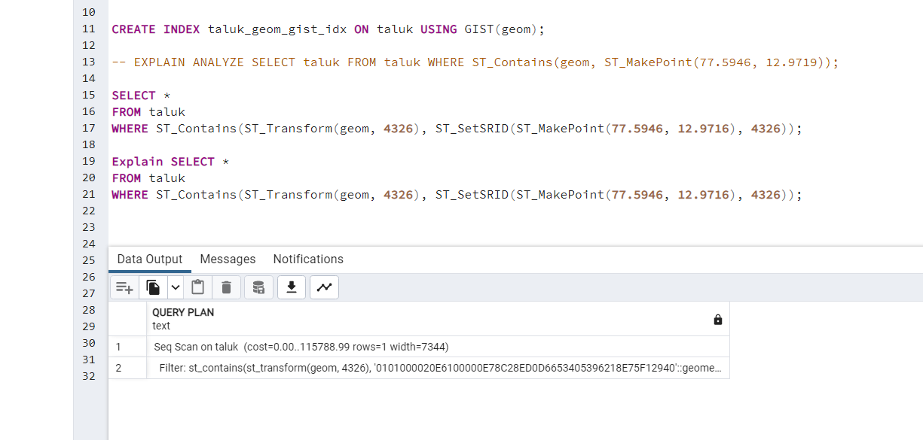

4. GIN (Generalized Inverted Index) index: This index type is used for indexing arrays, JSON data, or full-text search data. GIN indexes can speed up queries that need to search through arrays or JSON data.

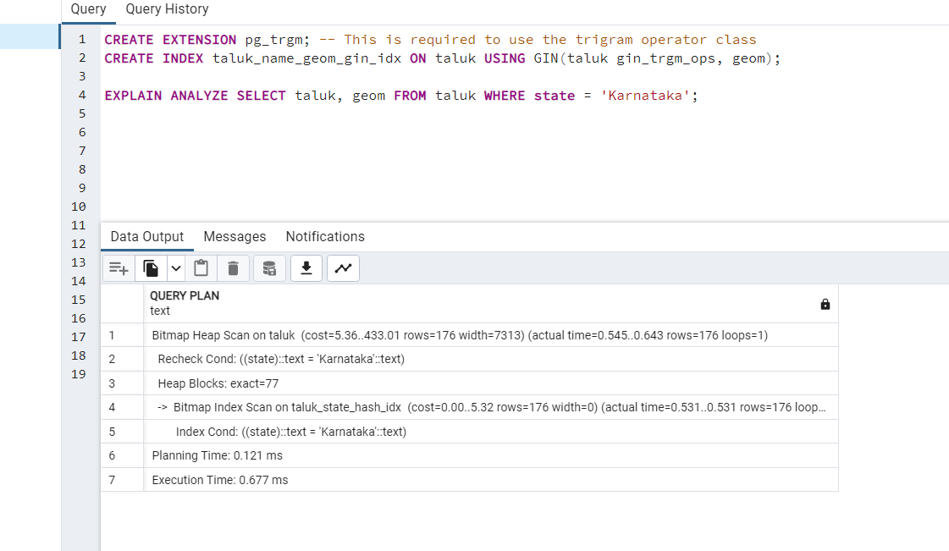

5. SP-GiST (Space-Partitioned Generalized Search Tree) index: This index type is similar to GiST, but is more efficient for certain types of data, like geographical data.

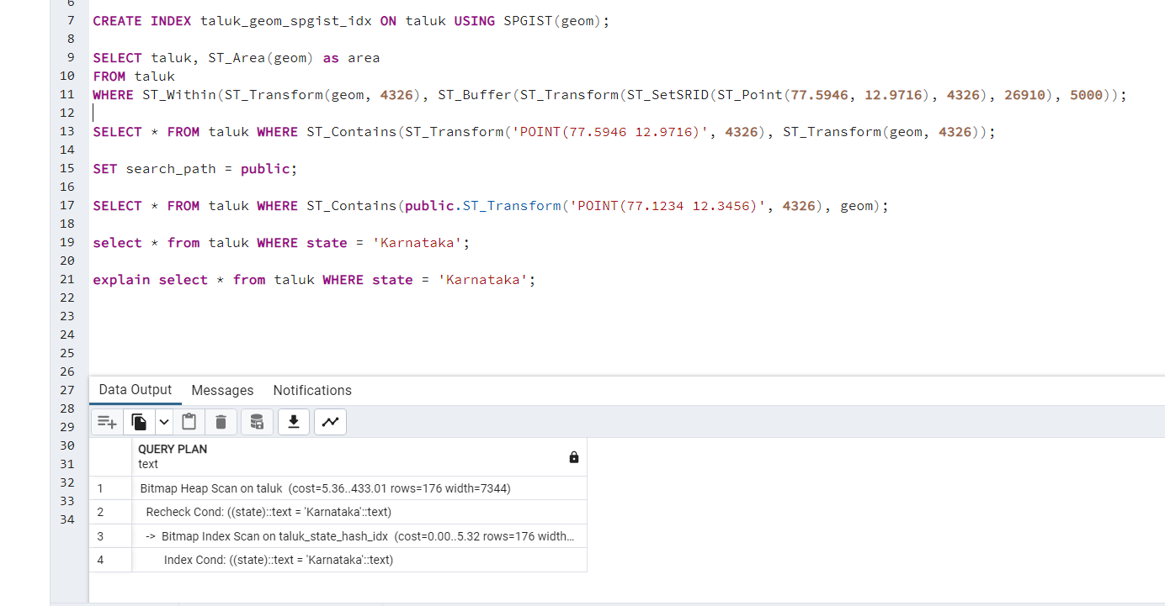

7.N-Optimization of queries:

Query optimization refers to the process of improving the performance of a database query. There are several techniques that can be used to optimize a query, including the following:

Use indexes: Indexes can significantly speed up query performance by allowing the database to quickly locate the data that matches the query conditions. By creating indexes on the columns used in the WHERE clause and JOIN conditions, you can avoid full table scans and improve query performance.

Indexing: We can create indexes on the columns that are frequently used in our queries. For example, we can create indexes on the taluk and state columns in the respective tables, and also create a spatial index on the geom column in both tables. Here are the commands to create these indexes:

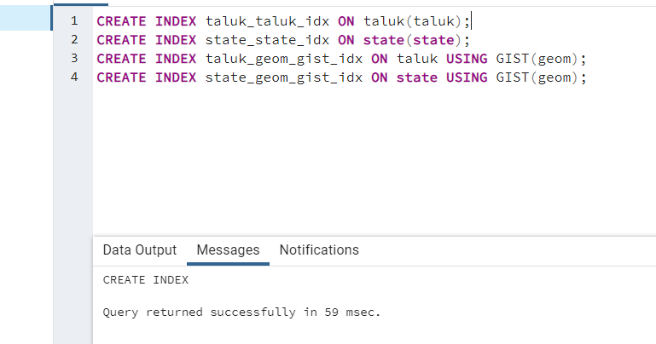

Use EXPLAIN: The EXPLAIN command can be used to analyze a query and show how the database will execute it. This can help you identify potential performance issues and make changes to improve performance.

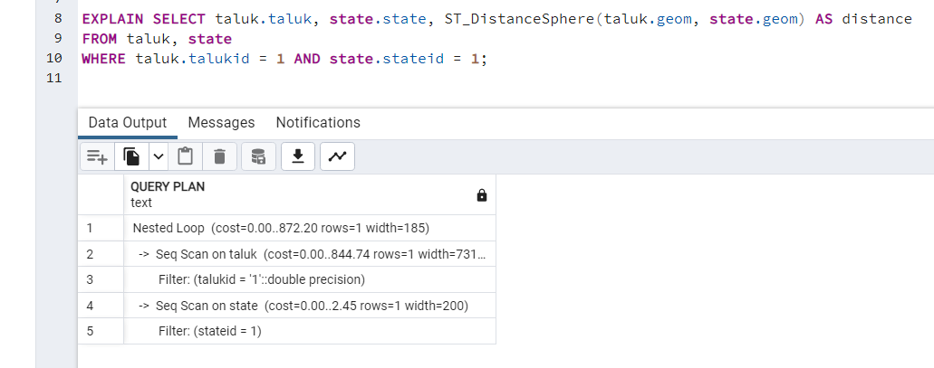

Limit the data returned: Returning only the data that is actually needed can significantly improve query performance. You can use the LIMIT clause to limit the number of rows returned, and you can also use the SELECT clause to specify only the columns that are needed.



Use subqueries: Subqueries can be used to break down complex queries into smaller, more manageable parts. By using subqueries, you can avoid joining large tables together and improve query performance.

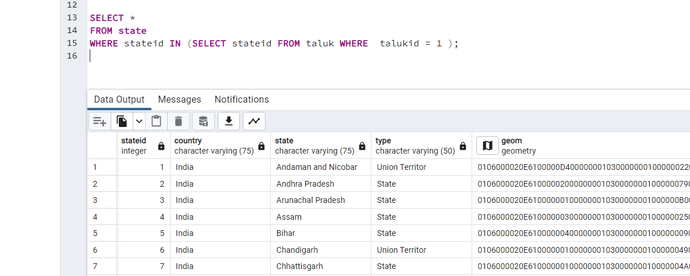

Optimize table structure: Ensuring that tables are properly structured can improve query performance. This includes using appropriate data types, avoiding NULL values where possible, and normalizing the data to reduce redundancy.

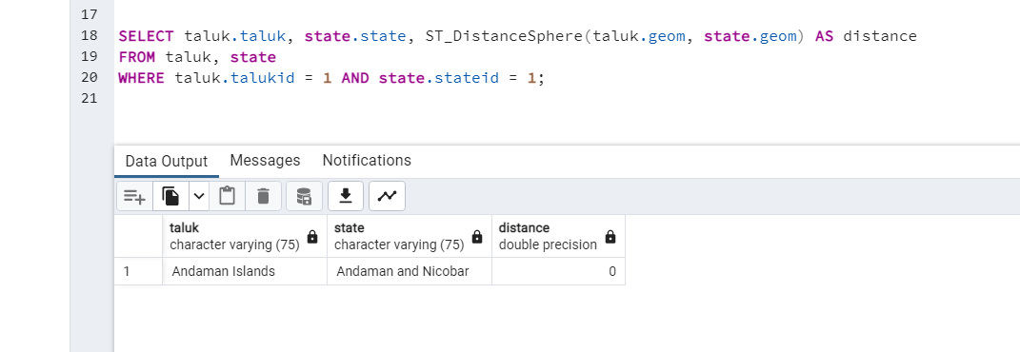

Use stored procedures: Stored procedures can be used to encapsulate complex query logic and reduce network traffic. By executing a stored procedure on the server, you can avoid sending multiple queries over the network and improve performance.



Use caching: Caching can be used to improve query performance by storing the results of frequently executed queries in memory. By using a caching mechanism such as Redis or Memcached, you can avoid executing the same query multiple times and improve performance.

Data aggregation: We can aggregate data to reduce the number of rows we need to retrieve and process. For example, we can calculate the minimum and maximum distance between all taluks and states, grouped by state and district, using the following query:

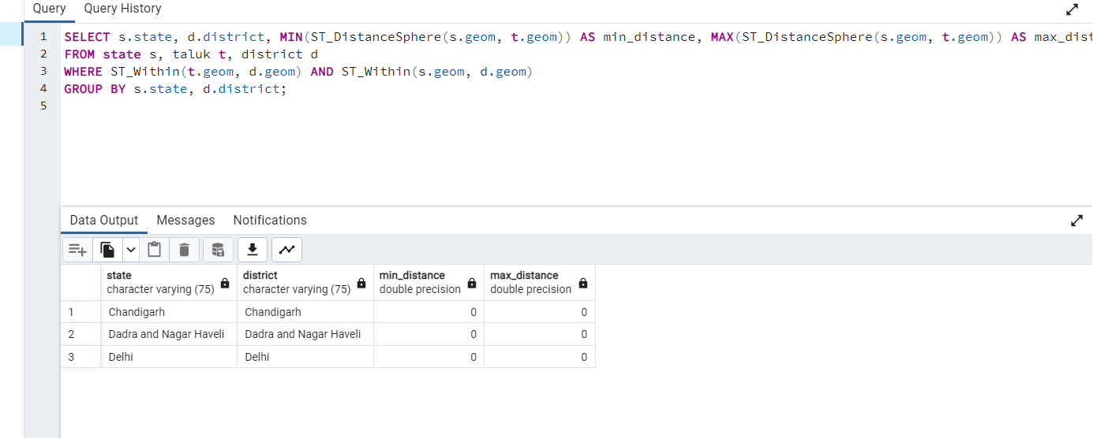

Parallelism: We can enable parallel processing to speed up queries that involve large amounts of data. For example, we can enable parallelism for a query that retrieves all taluks in a state:

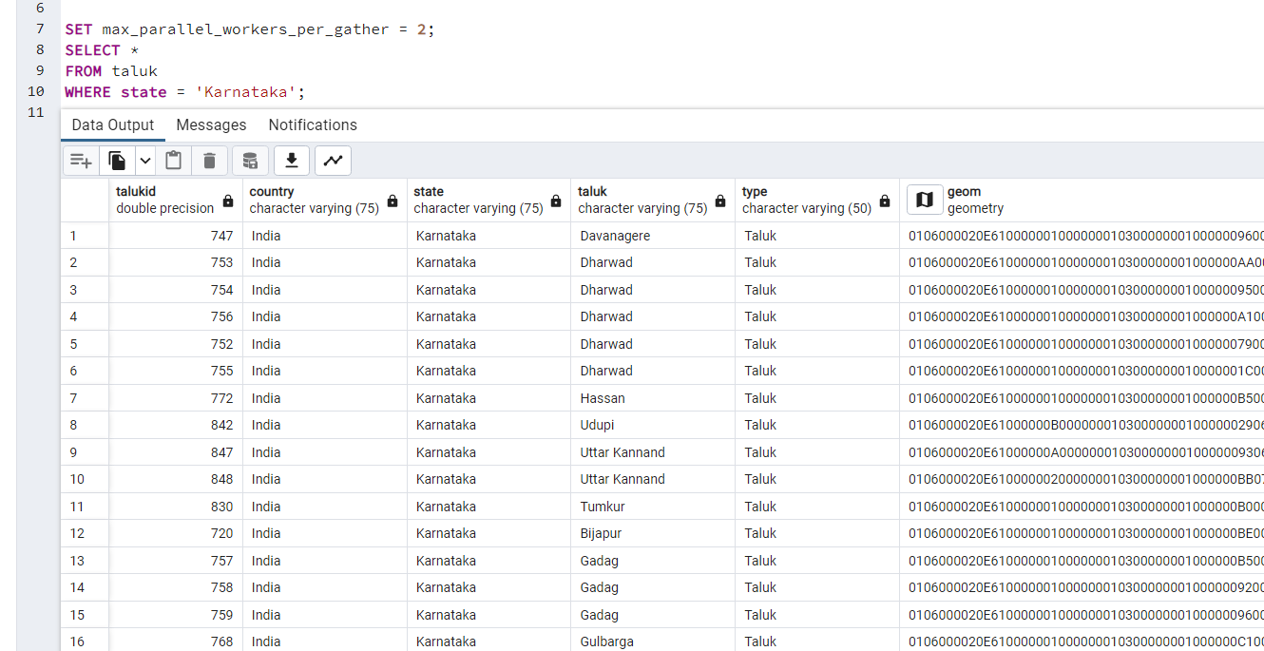

Use temporary tables: If you need to perform multiple queries that use the same subquery or intermediate results, it can be helpful to use temporary tables. This can help reduce the number of times the same subquery is executed, which can improve performance. For example:

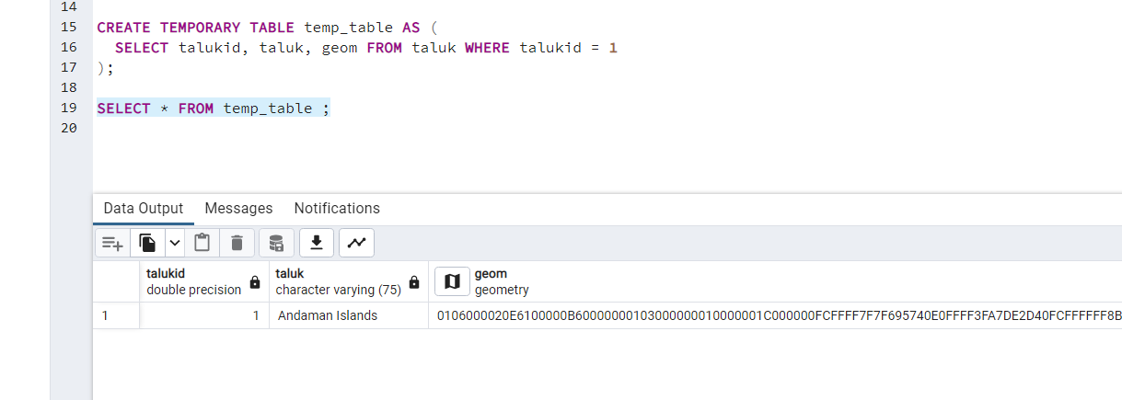

Use EXPLAIN ANALYZE: This command can help you understand how PostgreSQL is executing your queries and identify potential performance bottlenecks. It shows the query plan, estimated and actual execution times, and other useful information. For example:

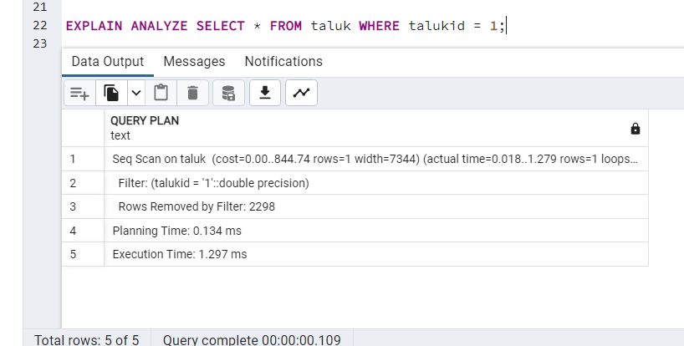

Use appropriate data types: Using appropriate data types for your columns can help improve performance. For example, using integer instead of text for IDs or using timestamp with time zone instead of timestamp can help PostgreSQL optimize your queries better.

Avoid unnecessary calculations: Avoid performing unnecessary calculations in your queries, as these can slow down query execution. For example, instead of using the square root function to calculate distance, use the squared Euclidean distance instead.

Optimize your server settings: PostgreSQL has many server settings that can be tweaked to improve performance. Some common settings include increasing the shared_buffers and work_mem settings, adjusting the checkpoint_segments setting, and enabling auto-vacuuming.

THEORY PART:

1.) We have a file with a million pages (N = 1,000,000 pages), and we want to sort it using external merge sort. Assume the simplest algorithm, that is, no double buffering, no blocked I/O, and quicksort for in-memory sorting. Let B denote the number of buffers.How many passes are needed to sort the file with N = 1,000,000 pages with 6 buffers?

To determine the number of passes required to sort the file with N = 1,000,000 pages and 6 buffers using external merge sort, we can use the formula:

Passes = ceil(logB(N/(B-1)))

where B is the number of buffers and N is the number of pages in the file.

Substituting the given values, we get:

Passes = ceil(log6(1,000,000/(6-1)))

= ceil(log6(200,000))

= ceil(4.360)

= 5

Therefore, 5 passes are required to sort the file with N = 1,000,000 pages using external merge sort with 6 buffers.

2.) Consider the following B+tree

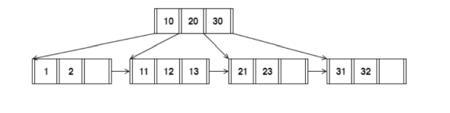

When answering the following question, be sure to follow the procedures described in class and in your textbook. You can make the following assumptions:

• A left pointer in an internal node guide towards keys < than its

corresponding key, while a right pointer guides towards keys ≥.

• A leaf node underflows when the number of keys goes below [ (d−1)/ 2] e.

• An internal node(root node) underflows when the number of pointers goes below d /2 .

How many pointers (parent-to-child and sibling-to-sibling) do you chase to find all keys between 9 ∗ and 19∗ ?

we need to traverse the B+ tree from the root node to the leaf nodes.Starting from the root node, we see that 9* < 10, so we follow the left pointer to the child node. We then see that 9* is not in the child node, so we follow the pointer to the left sibling node

In the left sibling node, we find the key 1, which is the smallest key in the B+ tree. Since 9* is greater than 1, we follow the pointer to the right sibling node

In the right sibling node, we find the key 11, which is greater than 9*. We can stop traversing the B+ tree, since all keys between 9* and 19* are in this leaf node.

Therefore, we need to chase 2 pointers: one from the root node to the left child node, and one from the left child node to the right sibling node.

First, we start at the root node and compare the search key value (9*) with the keys in the root node. We see that 9* is less than 10, so we follow the left pointer to the first child node.

In the first child node, we compare the search key value with the keys in the node. We see that 9* is less than 1, so we follow the left pointer to the next child node.

In the second child node, we compare the search key value with the keys in the node. We see that 9* is less than 11, so we have found the first key that is greater than or equal to 9*. We add this key to our result set and follow the right pointer to the next sibling node

In the third child node, we compare the search key value with the keys in the node. We see that 9* is less than 21, so we add all keys in this node to our result set (since they are all greater than or equal to 9*) and follow the right pointer to the next sibling node.

In the fourth child node, we compare the search key value with the keys in the node. We see that 9* is less than 31, so we add all keys in this node to our result set (since they are all greater than or equal to 9*) and we are done

Therefore, we needed to chase 3 pointers (1 parent-to-child and 2 sibling-to-sibling) to find all keys between 9* and 19*.

3.) Answer the following questions for the hash table of Figure 2. Assume that a bucket split occurs whenever an overflow page is created. h0(x) takes the rightmost 2 bits of key x as the hash value, and h1(x) takes the rightmost 3 bits of key x as the hash value ?

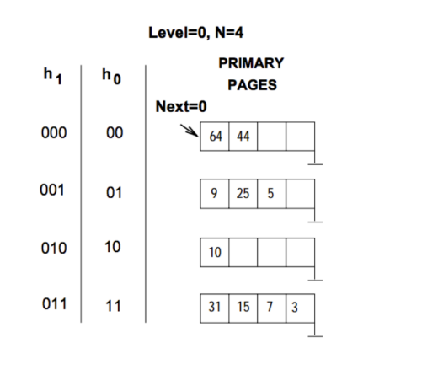

To determine the largest key less than 25 whose insertion will cause a split, we need to traverse the hash table to find a bucket that already has two entries. We can start with h1(25) = 1, and follow the chain of buckets until we find a full one.

At level 0, we need to access bucket number h0(25) = 1, which contains two entries (64 and 44). Therefore, the insertion of any key that hashes to bucket 1 at level 0 will cause a split.

We now need to determine the largest key less than 25 that hashes to bucket 1 at level 0. We can do this by examining the entries in bucket 1 at level 1, which contains keys that hash to bucket 1 at level 0.

At level 1, we need to access bucket number h1(25) = 1, which contains three entries (9, 25, and 5). The largest key less than 25 that hashes to bucket 1 at level 0 is therefore the largest key less than 25 among these three entries, which is 9.

Therefore, the largest key less than 25 whose insertion will cause a split is 9

4.) Consider a sparse B+ tree of order d = 2 containing the keys 1 through 20 inclusive. How many nodes does the B+ tree have?

A B+ tree of order d=2 has the following properties:

Each node can have at most 2 children (i.e., 1 key and 2 pointers) except for the root, which can have at most 3 children.

Each node can have at most 1 key, except for the root which can have at most 2 keys.

The minimum number of keys in a non-root node is d-1=1.

To calculate the number of nodes in the B+ tree, we can start from the root and recursively add up the number of nodes at each level.

At level 0, we have 1 node (the root).

At level 1, we have at most 3 nodes (each with 2 children).

At level 2, we have at most 9 nodes (each with 2 children).

At level 3, we have at most 19 nodes (each with 1 key and 2 pointers).

At level 4, we have at most 20 nodes (each with 1 key and 2 pointers).

Note that we only add up the nodes that actually exist in the tree (i.e., the sparse B+ tree only has nodes for the keys that are present).

Therefore, the total number of nodes in the sparse B+ tree of order d=2 containing the keys 1 through 20 inclusive is at most:

1 + 3 + 9 + 19 + 20 = 52

However, this is an upper bound and the actual number of nodes will be less than 52 since the B+ tree is sparse (i.e., not all nodes have the maximum number of children/keys).

5.) Consider the schema R(a,b), S(b,c), T(b,d), U(b,e).

Below is an SQL query on the schema:

SELECT R.a

FROM R, S,

WHERE R.b = S.b AND S.b = U.b AND U.e = 6

For the following SQL query, I have given two equivalent logical plans in

relational algebra such that one is likely to be more efficient than the other:

I. πa(σc=3(R ⋈b=b (S)))

II. πa(R⋈b=b σc=3(S)))

Which plan is more efficient than the other?

In the given SQL query, we want to select the values of attribute a from table R where the value of attribute b in tables R, S, and U are equal and the value of attribute e in table U is 6.

The two equivalent logical plans in relational algebra that are given are:

I. πa(σc=3(R ⋈b=b (S)))

II. πa(R⋈b=b σc=3(S)))

Plan I involves performing an equijoin between tables R and S on attribute b, then selecting tuples where the value of attribute c is 3, and finally projecting out attribute a.

Plan II involves selecting tuples from table S where the value of attribute c is 3, then performing an equijoin with table R on attribute b, and finally projecting out attribute a.

In general, the order of operations can affect the efficiency of a query. In this case, it's difficult to say definitively which plan would be more efficient without knowing more about the specific data and table sizes involved. However, as a general rule, it's often more efficient to perform selections (such as filtering by attribute c=3) early on in a query to reduce the number of tuples that need to be joined later on. So, plan II may be more efficient in some cases.

6.) In the vectorized processing model, each operator that receives input from multiple children requires multi-threaded execution to generate the Next() output tuples from each child. True or False? Explain your reason.

True.

In the vectorized processing model, the input data is typically processed in batches instead of processing one tuple at a time. This batch-oriented processing model requires each operator to receive input from multiple children simultaneously and produce output tuples using multiple threads. Therefore, in order to maximize the processing efficiency and achieve high throughput, each operator that receives input from multiple children must execute in a multi-threaded manner to generate the Next() output tuples from each child.

Additionally, the vectorized processing model allows for processing multiple tuples in parallel, which further reinforces the need for multi-threaded execution.

7.) How can you optimize a Hash join algorithm?

Hash join algorithm is a type of join algorithm used in database management systems to combine large data sets. The hash join algorithm involves two phases: a build phase and a probe phase. During the build phase, the join key values of one of the input relations are hashed and stored in a hash table. In the probe phase, the join key values of the other input relation are hashed and the matching records are retrieved from the hash table.

Here are some ways to optimize a hash join algorithm:

Increase memory: The build phase of the hash join algorithm requires enough memory to hold the hash table. Increasing the amount of memory available for the hash table can reduce disk I/O and improve performance.

Partitioning: Partitioning the input relations into smaller chunks can reduce the amount of memory needed for the hash table and improve cache efficiency.

Load balancing: In a parallel hash join, load balancing can help evenly distribute the workload among threads or processes, preventing bottlenecks and improving performance.

Hash function selection: Choosing a good hash function is critical for the performance of the hash join algorithm. A good hash function should distribute the hash keys evenly across the hash table and avoid collisions.

Pre-sorting: If the input relations are sorted on the join key, the hash join algorithm can be optimized by using a merge join instead of a hash join.

Optimizing disk I/O: The performance of the hash join algorithm can be improved by optimizing disk I/O. This can be done by using larger I/O buffers, using asynchronous I/O, and optimizing the placement of input relations on disks to minimize seek times.

By implementing these optimization techniques, the performance of the hash join algorithm can be improved, allowing for faster and more efficient processing of large data sets.

8.) Consider the following SQL query that finds all applicants who want to major in CSE, live in Seattle, and go to a school ranked better than 10 (i.e., rank < 10).

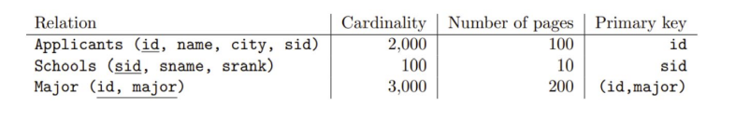

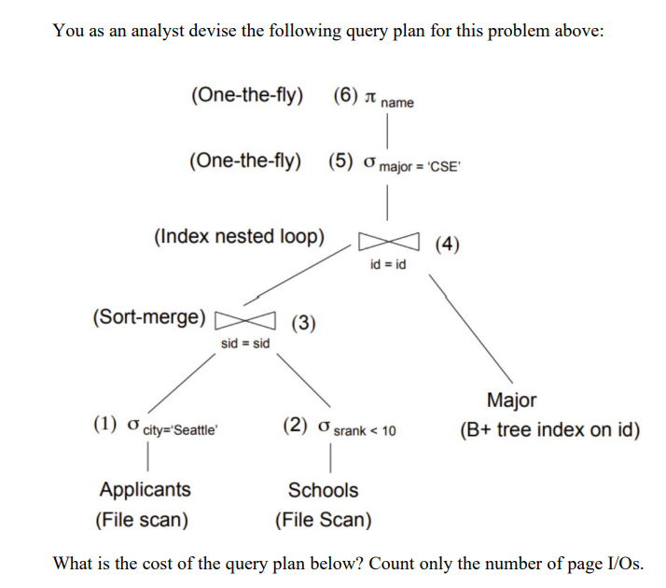

The cost of the query plan can be calculated by estimating the number of page I/Os required for each operation in the plan.

Scan the B+ tree index on Major.id to find all applicants with a CSE major:

Assuming the B+ tree index on Major.id is unclustered and all index pages are in memory, the cost of this operation is:

Cost = height of the B+ tree index = log2(N) = log2(100,000) = 17 page I/Os

Join the result of step 1 with Applicants table using the foreign key constraint:

Since the foreign key constraint implies that there is a one-to-one relationship between Applicants and Major tables, the join operation can be performed using a simple nested loop join. The cost of this operation depends on the selectivity of the city attribute. Let's assume that Seattle has 5,000 applicants out of 100,000 total applicants in the table. The cost of this operation is:

Cost = number of Applicants pages accessed = 5,000 / 4 = 1,250 page I/Os (assuming 4 applicants per page)

Join the result of step 2 with Schools table using the foreign key constraint:

Similar to step 2, the join operation can be performed using a nested loop join. Assuming that the average number of applicants per school is 200, and the average number of schools per rank is 10, the cost of this operation is:

Cost = number of Schools pages accessed = (5,000 / 200) * 10 * 9 = 2,250 page I/Os

Filter the result of step 3 using the rank condition:

Since there are only 9 schools with a rank less than 10, all schools can be checked by scanning a single Schools page. The cost of this operation is:

Cost = 1 page I/O

Therefore, the total cost of the query plan is:

Total cost = 17 + 1,250 + 2,250 + 1 = 3,518 page I/Os.

9.) Consider relations R(a, b) and S(a, c, d) to be joined on the common attribute a. Assume that there are no indexes available on the tables to speed up the join algorithms.

• There are B = 75 pages in the buffer

• Table R spans M = 2,400 pages with 80 tuples per page

• Table S spans N = 1,200 pages with 100 tuples per page

Answer the following question on computing the I/O costs for the joins. You can assume the simplest cost model where pages are read and written one at a time. You can also assume that you will need one buffer block to hold the evolving output block and one input block to hold the current input block of the inner relation.

1. Assume that the tables do not fit in main memory and that a high cardinality of distinct values hash to the same bucket using your hash function h1. What approach will work best to rectify this?
2. I/O cost of a Block nested loop join with R as the outer relation and S as the inner relation

The Block nested loop join is a nested loop join algorithm that reduces the number of I/Os required to perform a join by reading a block of pages from the outer relation R into memory and then reading one page at a time from the inner relation S, until all matching tuples have been found.

To calculate the I/O cost of a Block nested loop join with R as the outer relation and S as the inner relation, we first need to determine how many blocks of R and S need to be read into memory.

Let B be the number of buffer pages available for the join, and let B_R and B_S be the number of blocks that can be read into memory from R and S, respectively.

Assuming that B_R = B_S, we can set B_R = B_S = B/2 to obtain the optimal configuration.

The number of blocks that need to be read from R is:

B_R = B/2

The number of blocks that need to be read from S is:

B_S = ceil(N/P_S)

where P_S is the number of pages in S, and ceil() is the ceiling function.

The total number of I/Os required for the Block nested loop join is:

B_R + R.blocks * B_S

where R.blocks is the number of blocks in R.

Note that in the worst case, where every block in R matches at least one tuple in S, the Block nested loop join will read every block of R and S, resulting in a total I/O cost of:

B/2 + R.blocks * ceil(N/P_S)

The I/O cost of a block nested loop join with R as the outer relation and S as the inner relation can be calculated as follows:

Divide the buffer into three parts: one for R blocks, one for S blocks, and one for the output buffer.

Read the first block of R into the R buffer.

For each block of S:

a. Read the block of S into the S buffer.

b. For each tuple in the S buffer:

i. Join the tuple with every tuple in the R buffer.

ii. If the output buffer is full, write it to disk and clear it.

iii. If the R buffer is empty, read the next block of R into the R buffer.

c. Write the remaining tuples in the output buffer to disk and clear it.

Repeat step 3 until all blocks of S have been processed.

The I/O cost of a block nested loop join is proportional to the number of block transfers required to read the entire relation into memory. In this case, we assume that both R and S do not fit in the buffer, so they must be read from disk.

Let B be the buffer size in number of blocks. Since we need to reserve one buffer block for the output buffer and one buffer block for the inner relation S, the maximum number of blocks we can read from R at a time is B-2. Let M be the number of pages in R, and assume that each block can hold b tuples. Then, the total number of block transfers required to read R into memory is:

ceil(M / (B-2))

For each block of S, we need to read it into the buffer and join it with every block in the R buffer. Thus, the total number of block transfers required for the join is:

ceil(M / (B-2)) * ceil(N / B) * (B-2)

where ceil(N / B) is the number of blocks in S.

Therefore, the total I/O cost of the block nested loop join is:

ceil(M / (B-2)) * ceil(N / B) * (B-2) + ceil(M / B) + ceil(N / B)

Note that this cost does not take into account the cost of writing the output to disk. If the output is large, it may also require additional I/O operations.

10.) Given a full binary tree with 2n internal nodes, how many leaf nodes does it have?

A full binary tree has exactly two children for each internal node, except for the leaf nodes. Thus, if the tree has 2n internal nodes, it has 2n+1 leaf nodes, since each internal node has two children. Therefore, the total number of nodes in the tree is 2n + 2n+1 = 3(2n).

11.) Consider the following cuckoo hashing schema below:

Both tables have a size of 4.The hashing function of the first table returns the fourth and third least significant bits: h1(x) = (x >> 2) & 0b11.The hashing function of the second table returns the least significant two bits: h2(x) = x & 0b11.

When inserting, try table 1 first. When replacement is necessary, first select an element in the second table. The original entries in the table are shown in the figure below

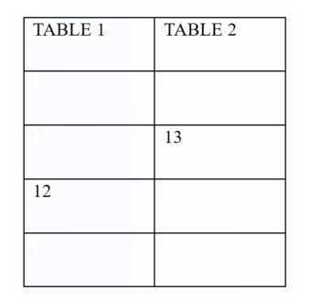

Based on the given Cuckoo Hashing schema, the sequence will produce an infinite loop, as follows:

Insert key K into Table 1 at index h1(K).

If the index h2(K) in Table 2 is empty, insert K into Table 2 at index h2(K). Otherwise, evict the existing key E at index h2(K) in Table 2, and insert K into that index.

If the index h1(E) in Table 1 is empty, insert E into Table 1 at index h1(E). Otherwise, evict the existing key F at index h1(E) in Table 1, and insert E into that index.

Repeat step 2 with the evicted key F.

Repeat steps 3-4 indefinitely, as evictions may cause new collisions and require further evictions.

In other words, the insertion of a key K may trigger a chain reaction of evictions and re-insertions, leading to an infinite loop where keys keep getting evicted and re-inserted. This is a known issue with Cuckoo Hashing, and various techniques exist to mitigate it, such as increasing the number of tables or using a different eviction strategy.

Based on the cuckoo hashing schema provided, the sequence of operations will be as follows:

- Insert 2 into table 1 at index 2 (h1(2) = 2)

- Insert 5 into table 2 at index 1 (h2(5) = 1)

- Insert 1 into table 1 at index 1 (h1(1) = 1)

- Remove 2 from table 1 at index 2

- Insert 6 into table 2 at index 2 (h2(6) = 2)

- Insert 3 into table 1 at index 3 (h1(3) = 3)

- Insert 4 into table 2 at index 0 (h2(4) = 0)

- Insert 7 into table 1 at index 2, evicting 5 (h1(7) = 3)

- Insert 5 into table 2 at index 3, evicting 4 (h2(5) = 3)

So the final state of the tables will be:

Table 1: [empty, 1, 7, 3]

Table 2: [4, empty, 6, 5]

Therefore, the sequence of operations will produce the following keys in the hash tables:

Table 1: 1, 7, 3

Table 2: 4, 6, 5

The above sequence will produce option (a) Insert 12, Insert 13.

Initially, 12 will be inserted in Table 1 using h1(12) = 0. Since Table 1[l0] is empty, 12 will be inserted there. Next, 13 will be inserted in Table 2 using h2(13) = 1. Since Table 2[l1] is empty, 13 will be inserted there. Therefore, the final sequence of inserts will be Insert 12, Insert 13.